### ABSTRACT

CALDERON, VICTOR ALEJANDRO. Condition Dependent Performance Based Design. (Under the direction of Dr. Mervyn Kowalsky.)

Structures located in seismic prone regions are often subjected to multiple earthquakes. Multiple earthquakes can accumulate damage resulting in a deterioration of the seismic perfor- mance of a structure. In addition, aging of the structure can arise conditions in the structure such as corrosion that further propagate the deterioration. Past research has shown that the Park and Ang damage index (DI)(a demand parameter that quantifies damage) increases as damage aging conditions in the structures worsen or multiple seismic events are included in the analysis. This increases the probability of a structure to collapse. This research proposes to study the effects of multiple earthquakes and damage accumulation in RC structures by developing strain limit states fragility functions for different aging conditions. To achieve this it is also important to develop limit states that represent corroded reinforcing steel. A method to perform accelerated corrosion in passivated reinforcing steel is proposed. These corroded rebars are then subjected to tension test and buckled bar tension tests, which will later be used to define service limit state and damage control limit state. To show the relevance of this study a framework that incorporates corrosion models into a nonlinear time history analysis (NLTHA) is developed. A series of SDOF cantilever columns are subjected to a sweep of earthquakes. This preliminary results show that there is an increase in the probability of reaching a limit state when corrosion level increase. The results also show the dispersion of results by using PGA as the impact measure (IM), indicating the need for a better intensity measure. The end results of this research will be to (1) develop fragility curves that consider strain limit states to measure damage while incorporating different aging conditions, (2) establish limit states for corroded rebars, (3) inform the research community on the necessary methodology to accurately model corrosion for material testing and large scale testing of corroded reinforced members (4) consider the effects of multiple earthquakes for main shock sequences and mainshock-aftershock sequence (5) incorporate the results into the direct displacement based design methodology.

© Copyright 2020 by Victor Alejandro Calderon All Rights Reserved

Condition Dependent Performance Based Design

by

Victor Alejandro Calderon

A research proposal submitted to the Graduate Faculty of North Carolina State University

in partial fulfillment of the requirements for the Degree of

Doctor of Philosophy

Civil Construction and Environmental Engineering Raleigh, North Carolina

2020

APPROVED BY:

Dr. James Nau Dr. Mohammad Pour-Ghaz

Dr. Rudolf Seracino Dr. Thomas Birkland

Dr. Mervyn Kowalsky

Chair of Advisory Committee

### TABLE OF CONTENTS

LIST OF TABLES iv

LIST OF FIGURES v

Chapter 1 INTRODUCTION 1

1.1 Scope and layout 3

Chapter 2 LITERATURE REVIEW 4

* 1. Cumulative Damage 4
     1. Damage Index 4
     2. Probabilistic Approach 7

Chapter 3 Study Gap 9

* 1. Research Gap 9
  2. General Objectives 10
  3. Specific Objectives 10

Chapter 4 Methodology 12

* 1. Corrosion 12
     1. Time to corrosion 14
     2. Rate of corrosion 15
     3. Corrosion modified properties of reinforcing steel bars 16
     4. Physical test on corroded RC Structures 17
     5. Proposed Experimental campaign 18
     6. Modeling of corrosion for Structural Analysis 25
  2. Steel Strain Aging 26
     1. Metallurgical Process 26
     2. Strain aging effects in structures 26
  3. Multiple Seismic Events 28
     1. Earthquake Selection 28
     2. Discrete Modeling of Main Shock Series 29
     3. Multiple Main Shock Series 30
  4. Future Topics 30

Chapter 5 Analytical Model and Preliminary Results 31

* 1. Analytical Model 31
     1. Cantilever Column 31
     2. Strain Penetration 32
     3. Design Limit States 34
  2. Comparison with existing physical Tests 35
     1. Pristine Condition Columns 35
     2. Accelerated Corrosion Columns 37
  3. Analytical Framework 37
  4. Results from NLTHA 39
     1. Effect on structure response 39
     2. Cumulative distribution functions 41
     3. Results discussion 42

BIBLIOGRAPHY 43

### LIST OF TABLES

Table 4.1 Accelerated Corrosion to achieve Corrosion Levels. 23

Table 4.2 Corroded Rebar Test Matrix 24

Table 5.1 Design Limit States 35

Table 5.2 Analysis Matrix 39

### LIST OF FIGURES

Figure 2.1 Park and Ang conceptual scheme 5

Figure 4.1 Corrosion Process in Reinforcing Steel Bar [29] 13

Figure 4.2 Concrete ater to cement ratio vs rate of corrosion 15

Figure 4.3 Diameter decrease due to corrosion 16

Figure 4.4 Corrosion Level vs Time (years) 17

Figure 4.5 Force displacement response of RC Corroded Columns [28] 18

Figure 4.6 Corrosion Process for RC Column [28] 19

Figure 4.7 Corroded Rebars Stress-Strain Curves [28] 19

Figure 4.8 Rebars Passivation Process in Calcium Hydroxyde Pore Solution 21

Figure 4.9 Rebar Specimen Geometry 21

Figure 4.10 Rebars Ends Protection 21

Figure 4.11 Accelerated Corrosion Process 22

Figure 4.12 BBT Test sequence[4] 24

Figure 4.13 Corrosion Modeling for Structural Analysis 25

Figure 4.14 Strain Aging effect on Yield Strength vs Time (days) 27

Figure 4.15 Mainshock selection from PEER NGA West2 Database 29

Figure 5.1 Structural Model a) SDOF Column b) Structural Model 33

Figure 5.2 End point plastic hinge method [37] 33

Figure 5.3 Section of the RC Column 34

Figure 5.4 Force-Displacement results from experimental results [18] and analytical model 36

Figure 5.5 Force-Displacement results from experimental RC column with corrosion in logitudinal bar (CL=9.5%) results [24] and analytical model (shown in

lightblue) 38

Figure 5.6 Strain hysteresis from experimental RC column with corrosion in logitu-

dinal bar (CL=9.5%) results from analytical model 38

Figure 5.7 Force-Displacement results 40

Figure 5.8 Stress strain response for extreme rebar location 40

Figure 5.9 CDF of steel yielding limit state using IM=PGA 41

Figure 5.10 CDF of steel yielding limit state using *IM* = *Sd*(*T*1) 42

**Chapter 1**

**INTRODUCTION**

Structures are designed assuming their original condition remains intact through their service life. However, as structures age, they suffer various forms of degradation. In addition, they may be subjected to multiple discrete seismic events. Both of these items have some impact on structural performance. Consider an RC column and the limit state corresponding to bar buckling. The limit state displacement (∆) to achieve bar buckling for a pristine column is different from a column subjected to corrosion. Similarly, multiple small seismic events may predispose the column to suffer longitudinal bar buckling for a lower level of seismic intensity. It is the goal of this research to incorporate both of these effects into the definition of performance limit states. This may result in a change to the initial design of a structure.

Structures subjected to multiple events and aging conditions has become an important aspect of Performance-Based Earthquake Engineering (PBEE). Recent earthquakes sequences such as the Christchurch 2010, Umbria-Marche Earthquake 1997 and more recently the Puerto Rico Earthquakes 2020, have shown that structures after sustaining damage during a mainshock have then collapsed or sustained increased damage after being subjected to a large magnitude aftershock[1][5][30]. Researchers have used the Park and Ang Damage Index (DI) to quantify damage, this damage index is expressed as a two-term expression, the first term relates to the maximum displacement and the second term relates to the inelastic energy dissipation [46]. The second term is associated with the inelastic cyclic behavior of the structural components, in addition, the calibration factor applied to this term is very small and contributes little to the damage index. If the damage index renders the inelastic cyclic behavior as negligible, it cannot accurately represent damage. Further, this damage index uses calibrated data to determine the strength degradation parameter that has a degree of arbitrariness, which is undesirable [43]. In addition to the Park and Ang damage index, other measures of damage such as drift ratio based

limit states have been incorporated into the PEER Performance-Based Design Probabilistic Framework[33][16][38]. These studies show good agreement with an increase in the probability of damage or even collapse of a structure due to repeated loading or aging conditions, such as high corrosion levels (CL), however, these results are based on the limitations presented by these damage measures [38]. A more deterministic approach to measure damage is to use strain limits as indicators of damage for RC bridge columns, concrete compressive and reinforcing steel tensile strain limits are used as the damage measure [17]. These strain limits have been correlated to observed damage in large scale column tests. Therefore, it is our belief that our research will provide a realistic measure of the increase in damage for different limit states due to aging conditions and multiple earthquake loading.

In addition, structures can have an existing condition such as corrosion that furthers dete- riorates the structural performance of the structure. Corrosion is one of the aging conditions that more significantly deteriorates the seismic response of a structure. Thus it is important to determine the limit states of corroded reinforcing steel. Currently, the literature has developed expressions that correlate the level of corrosion to the decrease in strength of the reinforcing steel[47][9]. However, these studies have utilized an accelerated corrosion process that does not consider the protective film that is developed on the reinforcing steel surface when it is embed- ded in concrete, a process known as passivation of the reinforcing steel [29][13]. For corrosion to occur depasivation of the reinforcing steel must first occur. Depasivation of the reinforcing steel greatly affects the behavior of reinforcing steel and can significantly modify the measured prop- erties of the corroded reinforcing steel. Furthermore, no study has presented performance limit states on corroded reinforcement. Therefore, this research aims to close this gap by performing an experimental campaign. This experimental campaign consists of a series of tension tests and buckled bar tension tests that corroborate the material properties and define the performance limit states of corroded reinforcement. These results will then inform the computational model. Moreover, there is a high likelihood for a structure in a high seismic region to be subjected to more than one mainshock throughout its service life, thus, it is deemed important to consider the effects of multiple earthquakes. A series of condition-dependent nonlinear time history analyses are performed on a cantilever RC bridge column. The analysis assumes that a series of earthquakes occur throughout the lifetime of the structure while at the same time changing the properties of the structure as a function of the aging conditions (e.g. corrosion). At the end of each series, the main variables of the study are the limit state that was reached, the controlling mode of response (flexural or shear controlled), equivalent viscous damping and the accumulated deformations. The series of earthquakes proposed consists of (1) equally spaced

main shocks only, (2) main shock-aftershocks series.

In summary, this research will show how the effects of different aging conditions affect the performance of a structures, establish strain limit states as a measure of damage, determine the effect of corrosion in establishing performance limit states, define what are the effects of multiple earthquake in the functionality of a structure and finally incorporate the results into the Direct Displacement Based Design (DDBD) methodology.

## 1.1 Scope and layout

This research proposal describes the main components and objectives for the graduate studies of the author of this document. Chapter 2 contains the literature review which summarizes the state of the art in damage measurements and performance based design framework. Chapter 3 covers the research gap and objectives. Chapter 4 summarizes the experimental and analytical procedures relevant to this study. Chapter 5 details the processing of current results.

# Chapter 2

**LITERATURE REVIEW**

Bridges are designed based on discrete events assuming that the initial material and structure properties remain constant through the life of the bridge. The purpose of the research described is to study Condition Dependent Performance Based Design that considers the material and geometric properties as the structure ages, as well as the effects of multiple and discrete events on the achievement of prescribed limit states.

In this chapter, the available knowledge on the different topics that are available in the literature are synthesized. First, a review on the different definitions of commutative damage is presented then the main idea for this research is established and its required components.

## Cumulative Damage

There have been attempts by many researchers to establish the best way to account for the accumulation of damage. The measures are described in this section.

### Damage Index

The effect of cumulative damage in structures was studied by Park and Ang (1985) [46] in their study the authors proposed the Damage Index as shown in 2.1. The damage index was used as a measure to quantify damage in terms of the maximum experienced earthquake and the absorbed hysteretic energy.

*D* = ∆*m − β Eh*

(2.1)

∆*u Fy*∆*u*

∆*m*: Maximum deformation under earthquake

∆*u*: Ultimate deformation under monotonic loading

*Fy*: Calculated yield strength *Eh*: Total hysteretic energy *β*: Dimensionless constant

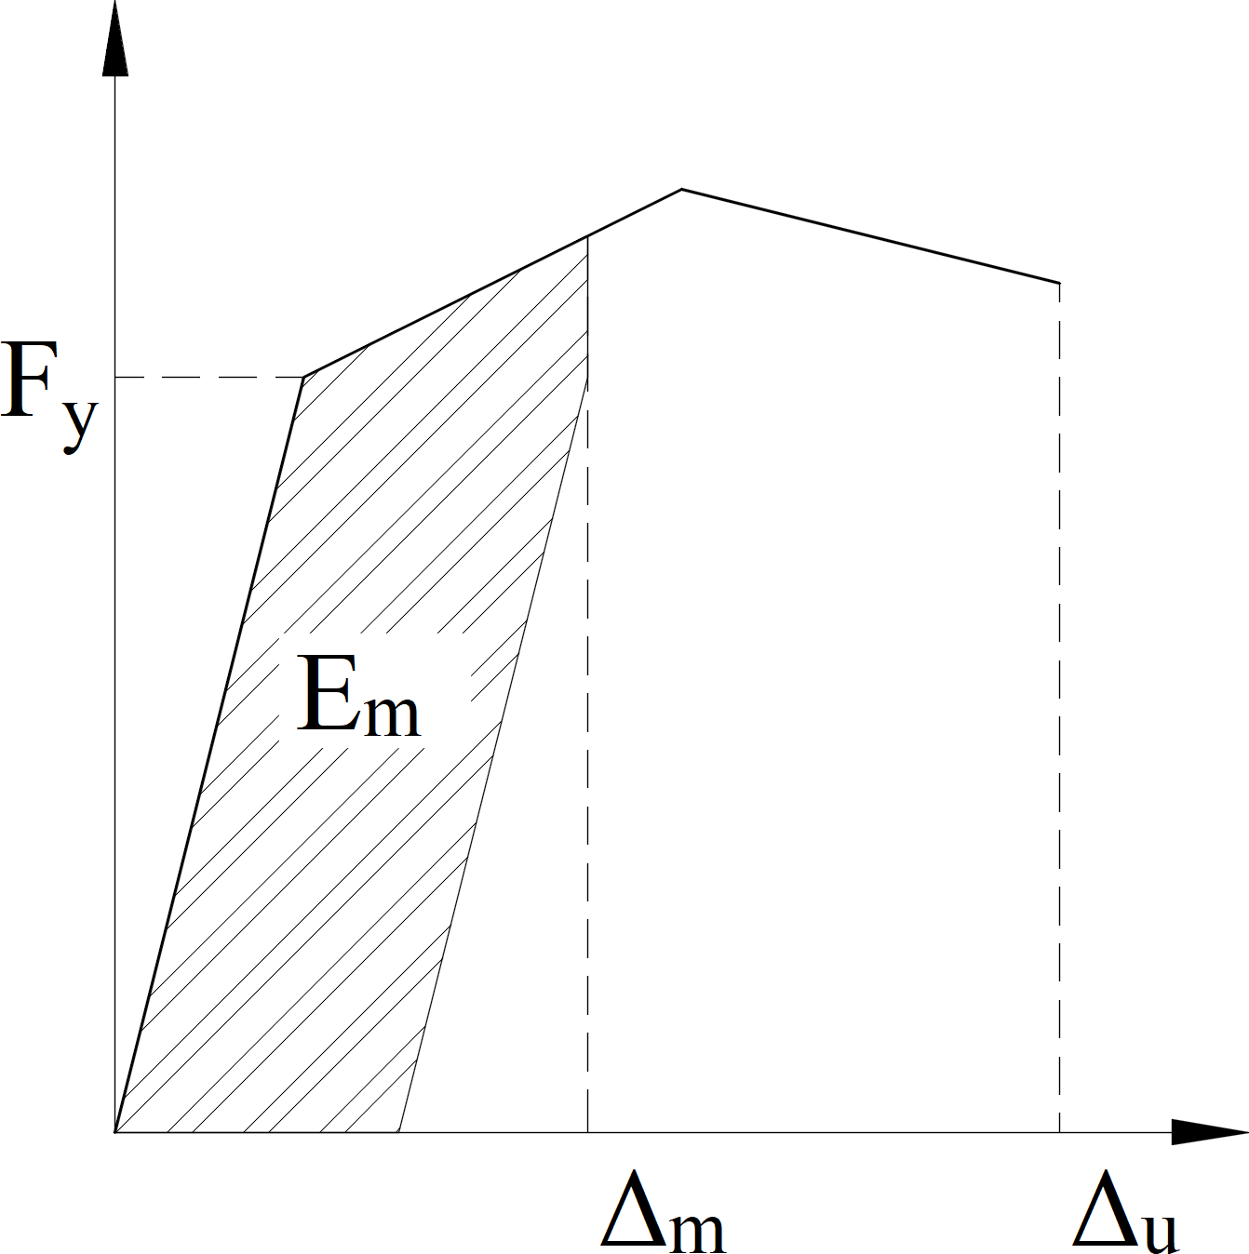

**Figure 2.1** Park and Ang conceptual scheme

Equation 2.1 was derived for concrete elements. The first term here is a simple, pseudo- static displacement measure. The second term accounts for cumulative damage. A figure on the concept is shown in Fig. 2.1. The advantages of this model are its simplicity and flexibility in adapting the model to correlate with experimental data.

This model has several limitations. Firstly the calibration of the *β* coefficient with observed damage has shown to be very low (*β* = 0*.*05*−*0*.*15) [46] [16], rendering the second term relatively inconsequential compared to the contribution of the first term. A sample result is taken from Gosh et al [16], which applied a modified version of the Park and Ang damage index in terms of the moment (*My*), the rotation (*θy*), and curvature ductility (*µ*) the modified model is expressed in equation Eq. 2.2.

*D* = *µm − β Eh*

(2.2)

*µu Myθyµu*

Using the following values: *µm* = 4*.*93; *µu* = 17*.*02; *My* = 8751*.*375; *θy* = 0*.*0042; *Eh* = 119*.*07; *β* = 0*.*05

And substituting in equation Eq. 2.2:

* + - * *D* =*µm − β Eh* = 0*.*3

*µu*

*Myθyµu*

* + - * **First term**:*µm* = 4*.*93 = 0*.*2897

*µu* 17*.*02

* + - * **Second term**: *β Eh* = 0*.*05 119*.*07 = 0*.*0103

*Myθyµu*

8751*.*375*∗*0*.*0042*∗*17*.*02

It can be seen that 97% of the damage index comes from the first term which is the elastic term and the inelastic part is only 3% of the total. In addition, the model was derived for reinforced concrete with poor shear detailing. The correlations observed in this model also showed the data to be sparse.

Depite its limitation, several studies have used or modified this model to study the effects of cumulative damage for different structures, of relevant importance are those performed by [23], who used a modified Park and Ang model, to model damagae at the local level for elements in a structural analysis program IDARC 3.0, in this software for the case of multiple degrees of freedom buildings they also added parameters to consider the damage at the inter-story level and the global model. Ghosh et al [16] developed a damage accumulation framework to develop probabilistic estimates of exceeding a damage index for multiple ground motions. Other regres- sions have been proposed by [20], [11], [36] but show no improvement in assessing the damage state of a structure. While these studies provide an insight into some of the characteristics of damage accumulation they rely on the Park and Ang model and therefore carry the same limitations.

Krawinkler (1987) [21] proposed a method that considered damage as a function of low cycle fatigue parameters, the form of the Krawinkler damage index for steel components, weldments, and local buckling has a general shape of the Miner model. This model relies on the accumulation of plastic deformations. While this model has proven to work well for the evaluation of individual steel structure elements, it does not provide a way to generalize damage for other types of structures.

### Probabilistic Approach

In recent years studies have focused on the effect of cumulative damage. These studies have focused on assessing the damage accumulation under different loading conditions such as mul- tiple earthquakes, corrosion and life span of the structure. Two main approaches to tackle this field of study have been observed:

* + - * Probabilistic Framework
      * Fragility Curves

#### Proababilistic Framework

One of the most widely used probabilistic framework is the Pacific Earthquake Engineering Research Center (PEER) Performance Based Design. PEER PBD can be expressed by the following equation:

*νDM* (*dmLS*) = *DDM |EDP* (*dm|edp*)*|, dGEDP |IM* (*edp|im*)*|| dνIM* (*im*)*|* (2.3)

Mackie et al [25] on the basis of the PEER PBD developed the Performance Based Damage Design (PBDD) and Performance Based Loss Design (PBLD) by defining the probabilistic demand, damage, and loss model parameters in terms of reinforced concrete column damage. The RC column damage was defined in terms of drift ratios defined for the limit states of concrete spalling, bar buckling and failure.

The authors show that for a given intensity measure (IM) and a confidence level of achieving a limit state, its is possible then to define the probability of exceeding that limit state.

While this methodology was able to define damage and incorporate it into the PEER PBD framework, the authors did not consider strain to define the limit states. Also recent research has shown that other intensity measures such as spectral displacement at effective first mode period (*Sd*(*T*1)) provide a better intensity measure [22].

#### Fragility Curves

Another common trend in this subject is the use of fragility curves to estimate the effect of damage in structures. Two main approaches were found in the literature. One of them relied on the Park and Ang Model Damage Index to define damage. While the second approach relates damage to drift.

Ghosh et al [16] formulated a damage accumulation framework. Their study relied on the Park and Ang Damage index explained in the previous section. The study performed a series of nonlinear time history analyses for two cases:

* + - * Using a constant main shock hazard occurrence rate (3 main shocks in a 50 year period)
      * Mainshock - Aftershock series using time-dependent aftershock hazard occurrence rate Evaluation of the damage index exceedance probability for the two cases was performed. The

results from this study show regression equations that statistically predict the damage index as a function of earthquake intensity and damage history. This study revealed that for both mainshock and aftershock scenarios there was a significant increase in the probability of damage index exceedance under repeated shock scenarios. While this study shows the importance of considering damage accumulation, these results have to be taken with caution since it carries the same disadvantages of the Park and Ang damage index.

Ghosh et al [15] also studied the effects of corrosion in time dependent seismic fragility curves. Their study characterizes corrosion in concrete columns as a continuous phenomenon that occurs as a function of time. Additionally, the authors considered the effects of corrosion in steel bridge bearings. The authors then ran a series of NLTHA analyses for different aging times of the structures. Based on those analysis time dependent fragility curves were presented. The results showed that as time increases, and as a consequence corrosion increases, the probability of exceeding a limit state increases. In this study limit states where defined on the basis of inter-story drifts which were obtained from experimental results and field observations [33]. It is important to mention that the limit states used in their study, were not defined on the basis of strains or other structural property rather from a survey performed in central southeastern United States departments of transportation on the premise of a range of experienced inter- story drifts and the time to repair them. Additionally assuming that corrosion is a continuous process has to be cautiously taken as valid since site information such as temperature, water to cement ratio, the addition of cementitious materials such as silica fume, and the environment (e.g. coastal vs inland) affect the rate of propagation of corrosion[40].

While these studies provide a general view on how damage increases the likelihood of ob- serving collapse or deterioration of the seismic performance, the methods used to arrive at those conclusions can be misleading since the definition of damage as either a Damage Index or Drift are not the best parameters to quantify the damage. It is our belief that strain-based limit states will provide a better understanding on the implications of damage accumulation.

# Chapter 3

**Study Gap**

## Research Gap

It is clear that while studies have tried to show the importance of damage and multiple shocks through the lifetime of a structure, it is important to develop a model that establishes what is the likelihood of achieving a limit state as the structure ages. In addition, it is important to understand the impacts of aging in bridge seismic performance. Furthermore, bridges in seismic areas can be subjected to more than a single mainshock and its corresponding aftershocks. Therefore a methodology that incorporates both aging and multiple events is needed.

Damage accumulation is topic that has been gaining momentum in the engineering com- munity since these efforts will better inform the potential future conditions of a structure to stakeholders such as state DOTs, building owners and practicing engineers, should the structure subjected to a further event. damage accumulation has been studied using the Park and Ang damage index or drift based limit states to measure damage accumulation. Different researchers have also included corrosion into their scope of analysis, which shows that aging conditions play an important role in the deterioration of a structure. In addition the literature uses the peak ground acceleration (PGA) as the controlling intensity measure (IM). This research will develop a parametric study using a series of single degree of freedom (SDOF) systems and subjecting them to different conditions such as corrosion, steel strain aging and strength aging among other. The SDOF structures will be subjected to a sweep of ground motions using nonlinear time history analysis to obtain maximum strain demands. With the results obtained fragility functions will be proposed for each limit state and aging condition. This research will provide the engineering community with a framework to account for damage in their analysis and guide decisions on the resiliency of a structure. In addition, this study will provide a methodology

in which the Direct Displacement-Based Design (DDBD) is modified to consider the effects of damage and conditions.

## General Objectives

The main goal of this research is to provide a methodology to consider damage into the PEER performance based design and demonstrate the implications of aging conditions and multiple earthquakes in the probability of collapse of a structure.

## Specific Objectives

* + - Incorporate different aging conditions and develop fragility curves that considers strain limit states as a measure of damage
    - Establish limit states for corroded rebars
    - Inform the research community on the necessary methodology to appropriately mimic real corrosion process in material experiments of corroded rebars, which can later be extrapolated to large scale testing of RC columns subjected to corrosion
    - Consider the effects of multiple earthquakes for two cases: (1) Mainshock sequences (2) Mainshock-Aftershock sequence
    - Incorporate these results into the Direct Displacement Based Design (DDBD) methodol- ogy, through the use of factors that correspond to the aging conditions.

g

# Chapter 4

**Methodology**

A methodology that incorporates the different sources of cumulative damage in RC structures is proposed. Different models of aging conditions that modify the material properties are studied, this are then incorporated into the analytical model.

The aging conditions focused on this research are:

* + - Corrosion
    - Strain aging

Other aging conditions will be added to this study.

## Corrosion

One of the main phenomena that affect the long term behavior of RC structures is corrosion of the reinforcing steel. Two types of corrosion are possible:

* + - Carbonation,
    - Chloride attack

The main source of corrosion in most RC structures is **Chloride Attack**, this is the one that will be the focus of this research.

Corrosion of steel in concrete is an electrochemical process [29] this corrosion may be gen- erated in two ways:

* + - Composition cells may be formed when two dissimilar metals are embedded in the concrete or when significant variations exist in the surface characteristics of steel
    - In the vicinity of steel, corrosion concentration cells are formed due to differences in the concentration of dissolved ions, such as alkalies and **chlorides**

The corrosion process of reinforced concrete structures under chloride attack consists in the loss of the protective film on the reinforcing steel surface, this process is known as **depassi- vation**, after which the initiation of corrosion occurs, the electrical resistivity and the oxygen content control corrosion. Figure 4.1 schematically show this process

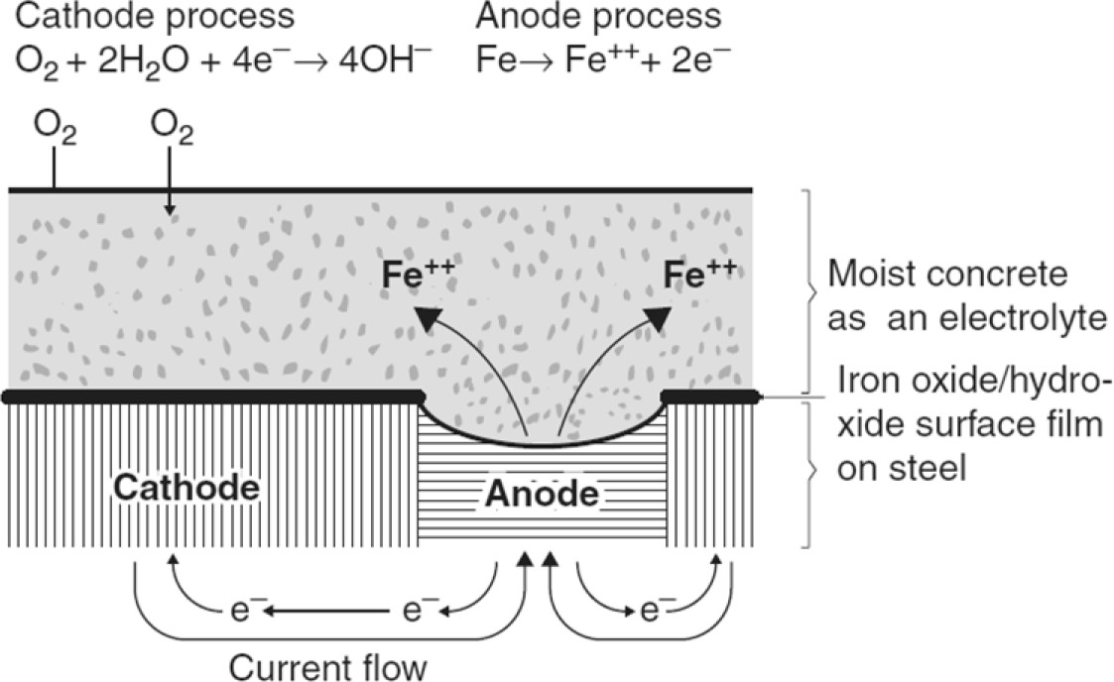

**Figure 4.1** Corrosion Process in Reinforcing Steel Bar [29]

Since corrosion plays an important role in the further deterioration of the seismic response of a structure, the following topics have been studied and later incorporated in the analysis:

1. Time to Initiation of Corrosion (Tcorr)
2. Corrosion growth in reinforcing steel
3. Mechanical Properties of Corroded Reinforcing Steel
4. Cyclic Test on Corroded RC Columns

### Time to corrosion

Time to corrosion refers to the corrosion initiation at which the passive film of the reinforcing steel is destroyed and reinforcement starts corroding actively. It has been established that reinforcing steel corrosion follows Fick’s law of diffusion [15][40][39][44]. Fick’s law is used to model the rate of chloride penetration into concrete as a function of concrete cover and time.

*∂C*(*x, t*)

*∂t* = *Dc*

*∂C*(*x, t*)

*∂x*2 (4.1)

*C*(*x, t*): Chloride ion concentration

*x*: Distance from concrete surface

*t*: Time in seconds of exposure to chloride ions

*Dc*: Chloride diffusion coefficient The solution of equation 4.1 is:

*C*(*x, t*) = *c*0

1 *− erf*

*x*

2*√*2 *Dct*

*−*1

(4.2)

In equation Eq. 4.2, if we consider a critical chloride corrosion threshold *Cr* , and a equi- librium chloride concentration *C*0 and solve for t, the time to corrosion can be calculated as [15]:

*Dc*: Diffusion Coefficient

*Tcorr* =

*x*2

4*Dc*

*erf −*1

*C*0 *− Ccr −*2

*C*0

(4.3)

*C*0: Equilibrium Chloride Concentration

*Cr*: Critical Chloride Concentration

Mean values for *C*0 and *Cr* have been previously defined by many researchers [15][42][10]. These values have been determined for environments that are controlled by **dicing salts**. The values of initiation of corrosion using this values would provide mean times to corrosion in the United States, however this values can be obtained for specific sites if desired.

### Rate of corrosion

To estimate the loss of steel cross section due to corrosion a time dependent corrosion rate model been developed [41][39], this model implies that corrosion rate decreases with time. As corrosion accumulates around the reinforcing steel, the corrosion byproducts prevent the uncorroded steel to react with the environment. The model is shown in Eq. 4.4. This model establishes that the corrosion rate is a function of the water to cement ratio (*w/c*) and the cover depth (*dc*).

*icorr*

= 37*.*5(1 *− w/c*)

*dc*

(4.4)

In Fig. 4.2 the behavior of this model for different values of *w/c* ratios is shown. It can be seen that at larger values of cover depth the rate of corrosion decreases rapidly and as the water cement ratio increases the rate of corrosion decreases.

**Figure 4.2** Concrete ater to cement ratio vs rate of corrosion

3

2.8

2.6

2.4

)

2

2.2

μA/cm 2

( dc=1 5/8 in

or 1.8

ic dc= 2 in

1.6 dc=3 in

1.4

1.2

1

0.35 0.375 0.4 0.425 0.45 0.475 0.5 0.525

w/c

With the rate of corrosion clearly defined, the evolution of corrosion of reinforcement can be calculated. Many researchers have used the model proposed by Vu et al [39][41][7][15] to respresent the evolution of corrosion in reinforcement, the model is shown in equation Eq. 4.5 . A graphical representation of the evolution of corrosion for a 3/4 inch diameter reinforcing steel

with a concrete cover of 1- is shown in Fig. 4.3. These results are shown for water to cement ratios ranging from 0.36-0.50. This range is representative of good quality concrete.

*dcorr*

(*t*) = *dbi*

1*.*0508(1 *− w/c*)(*t t*

*dc*

*− −*

*corr*

)0*.*71 (4.5)

*dbi*: Initial diameter of the bar (mm)

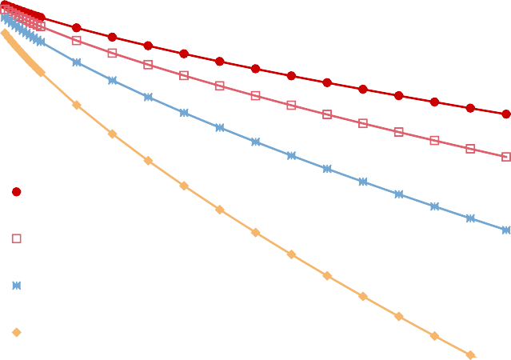

**Figure 4.3** Diameter decrease due to corrosion

0.75

in) 0.70

(

er

Diamet w/c=0.36

0.65 w/c=0.40

w/c=0.42 w/c=0.5

0.60

0 10 20 30 40 50 60 70 80

Time (Years)

The evolution of corrosion in reinforcing steel can be expressed in the percent loss of mass of a rebar. Since uniform corrosion is assumed this can be expressed in terms of the change in diameter. This is calculated in Eq. 4.6.

*CL* = *di − d*(*t*) 100 (4.6)

*∗*

*di*

The values obtained from Eq. 4.5 can then be used in Eq. 4.6 to obtain the variation of corrosion level as a fuction of time, shown in Fig. 4.4.

### Corrosion modified properties of reinforcing steel bars

In a study presented by Yuan et al [47] it was shown from experimental results that the me- chanical properties of steel change with the level of corrosion. An expression that shows the

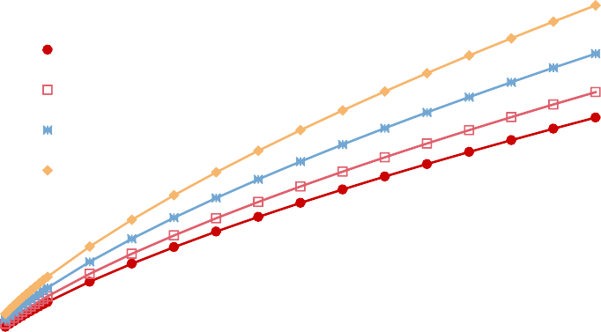

**Figure 4.4** Corrosion Level vs Time (years)

20%

15% w/c=0.36

(%)

l w/c=0.40

e

Lev w/c=0.42

10%

osion w/c=0.50

Corr

5%

0%

0 10 20 30 40 50 60 70

Time (Years)

variation of yield strength and ultimate strength were provided as follow:

*fy,C* = *fyo*(1 *−* 0*.*021*C*) (4.7)

*fu,C* = *fyo*(1*.*018 *−* 0*.*019*C*) *δs,C* = *δso*(1 *−* 0*.*021*C*) *εy,C* = *εyo*(1 *−* 0*.*021*C*)

These expressions are used in the analytical procedure and as shown in Chapter 5, they correlate well with the observed experimental work.

### Physical test on corroded RC Structures

Recent studies [24], [28] and [45] have been developed to assess the force-displacement relation- ships in cantilever RC columns. These columns were subjected to quasi-static loading protocol. These concrete columns were subjected to accelerated corrosion to obtain different corrosion levels (*CL*). The range of *CL* for these studies correspond to *CL* = 0% *−* 20%. In these studies the accelerated corrosion was performed via an electrochemical process directly applied to the reinforcing steel as shown in Fig. 4.5.

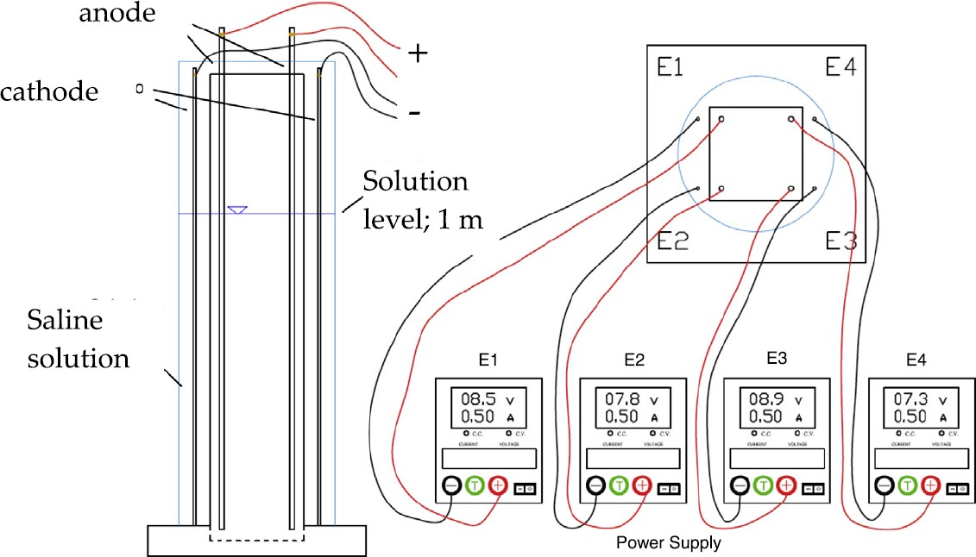

**Figure 4.5** Force displacement response of RC Corroded Columns [28]

The resulting force displacement response of these experiments is shown in Fig. 4.6. It can be seen that there is a reduction of he strength of the system and displacement capacity.

As stated in the previous section the mechanical properties of steel are affected by corrosion. In the previous studies [28] the authors performed tension tests on corroded reinforcing steel. In these tests a reduction in the mechanical properties of steel was observed as well as a reduction in the rupture strain *εsrup*, see Fig. 4.7.

While these studies show how corroded RC Columns behave under cyclic loading, they did not consider the generation of the protective film due to the alkaline environment of the concrete. This film can modify the mechanical properties of corroded steel. In addition, the accelerated corrosion process used a 3% *NaCl* concentration solution while the chloride attack in concrete usually has a 1.0% - 1.5% concentration of the same chloride. Therefore the results obtained from these studies do not accurately represent the actual conditions of corroded RC columns. Thus, an experimental campaign is proposed that will provide results on the mechanical behavior of corroded reinforcing steel inside concrete. This is discussed in the following subsection.

### Proposed Experimental campaign

As explained in the previous section the steel inside concrete generates a protective film and after chloride attack reaches the surface of the steel, this protective film starts to be eliminated. This same process will be simulated through the experimental campaign outlined here:

* + - 1. Passivation of the reinforcing steel

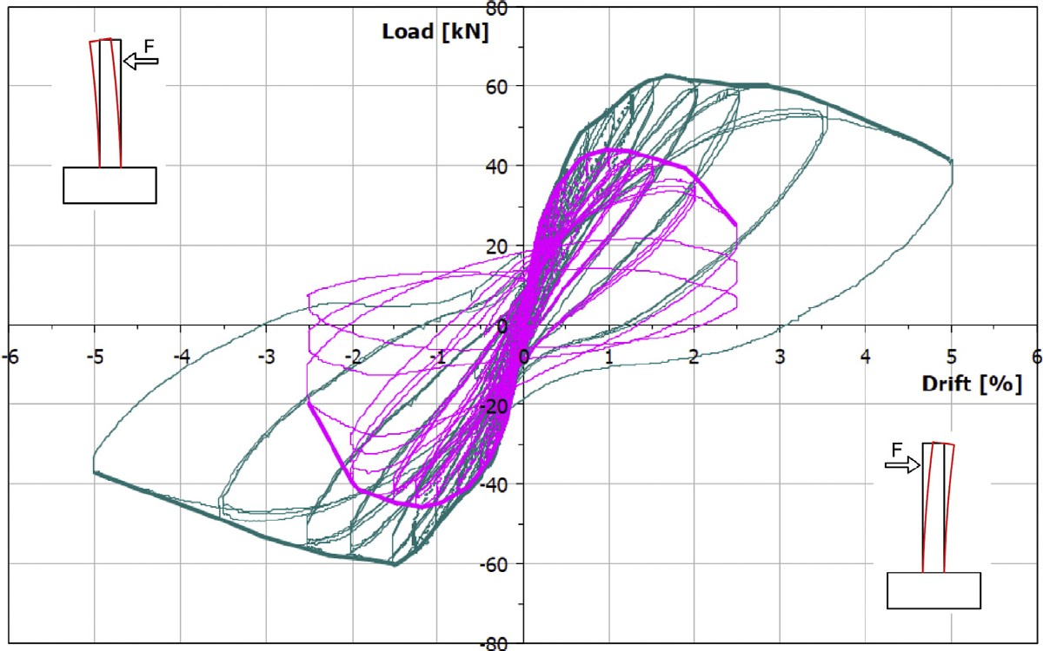

**Figure 4.6** Corrosion Process for RC Column [28]

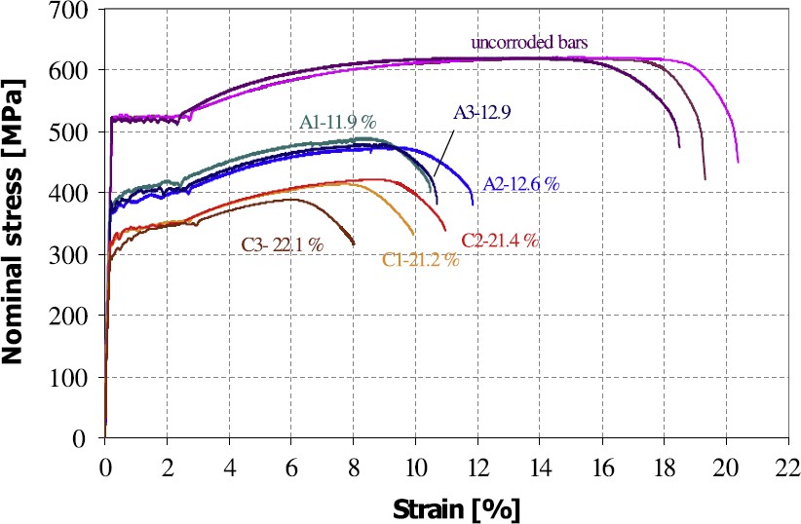

**Figure 4.7** Corroded Rebars Stress-Strain Curves [28]

* + - 1. Accelerated corrosion of Reinforcing Steel
      2. Tension Tests
      3. Buckled Bar Tension (BBT) Test

#### Passivation of reinforcing steel

Methods to generate the passive film on the reinforcing steel surface are available in the literature [14]. According to this study, it is possible to generate the passivation process in the same way as it occurs in reinforcing steel embedded in concrete by using an alkaline porous solution. The authors, studied ten different porous solutions, out of which five had all the alkali oxides that exist in the cement. Of these five solutions, the one that showed better performance in the quality of the protective oxides grown on rebar is shown here with its corresponding concentrations:

* Saturated Calcium Hydroxide *Ca*(*OH*)2
* Sodium Hydroxide *Na*(*OH*) (4.00 g/l)
* Potassium Hydroxide (*OH*) (11.22 g/l)
* Calcium Sulfate Dihydrate *Ca*(*SO*)4 + 2*H*2*O* (13.77 g/l)

This is the solution that will be used in this research to generate the passive film on the specimens.

To generate the passivation of the reinforcing steel, the rebars will be placed in a container with the pore solution for a minimum of 8 days. Anodic Polarization Tests will be measured on the rebars to determine the passive current density. A figure of this process is shown in Fig. 4.8. In addition, The ends of the rebars will be protected to prevent corrosion in these zones of the specimens, the protection at the ends is based on the standard ASTM G109-07 with some alterations. Figures Fig. 4.9 and Fig. 4.10 show the specimen geometry and the preparation of the ends of the rebars.

#### Accelerated corrosion of Reinforcing Steel

The accelerated corrosion will be done by using a galvanic cell. Different studies [14] have shown that for rebars with pasive films a concentration of 0.3 Moles of sodium chloride (*NaCl*) will start the depassivation process on the rebars. In the study presented here, the specimens will be subjected to a current of 5mA equivalent to 47*µA/cm*2. This current is sustained for a period of time according to Faraday’s Law until the desired level of corrosion is reached.

Seal

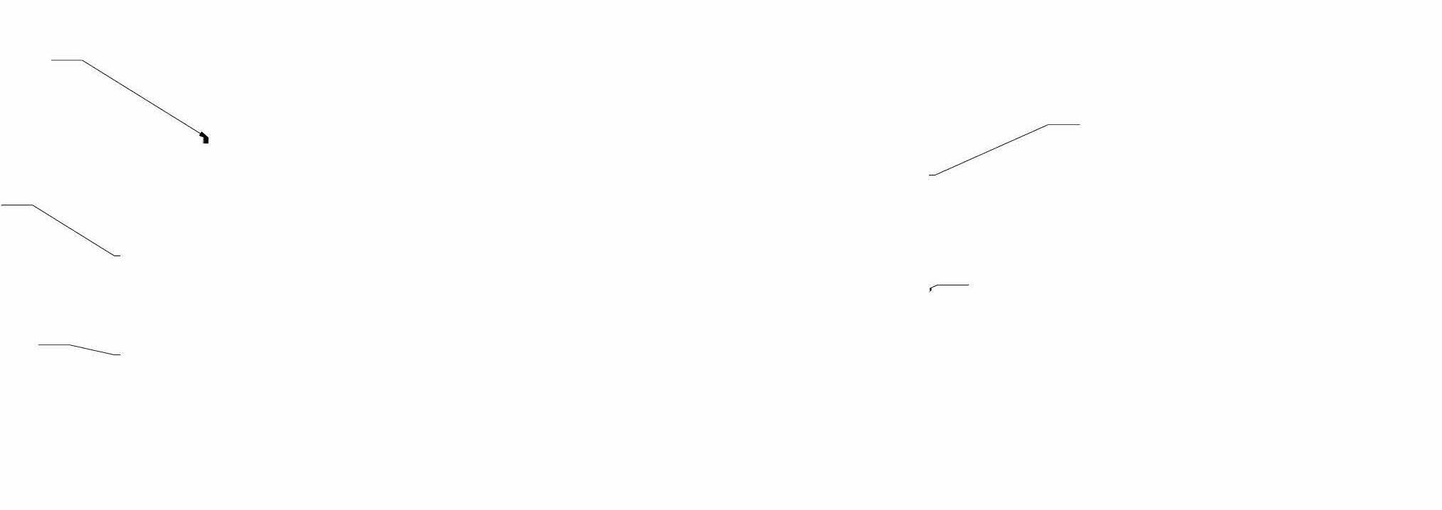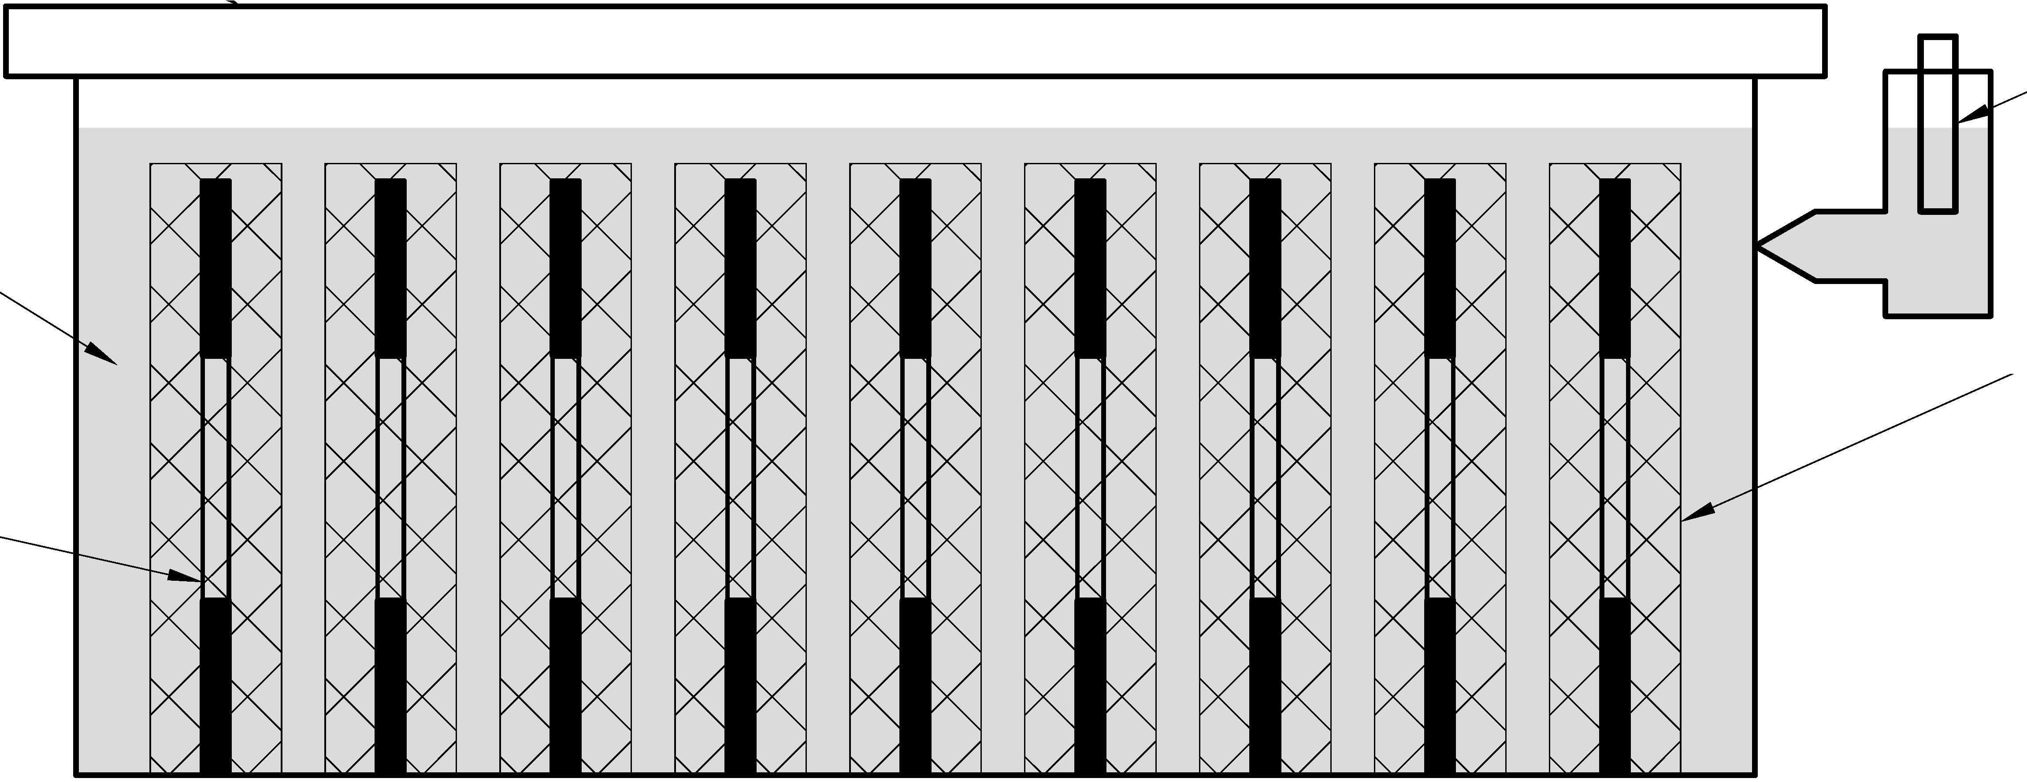

Calcium Hydroxyde

Pore Solution

Rebar (Working Electrode)

Reference Electrode (SCE)

Stainless Steel (Counter Electrode)

**Figure 4.8** Rebars Passivation Process in Calcium Hydroxyde Pore Solution

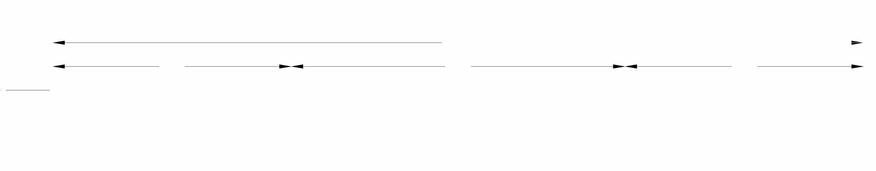

t

db

t

**5"**

17"

7"

**5"**

**Figure 4.9** Rebar Specimen Geometry

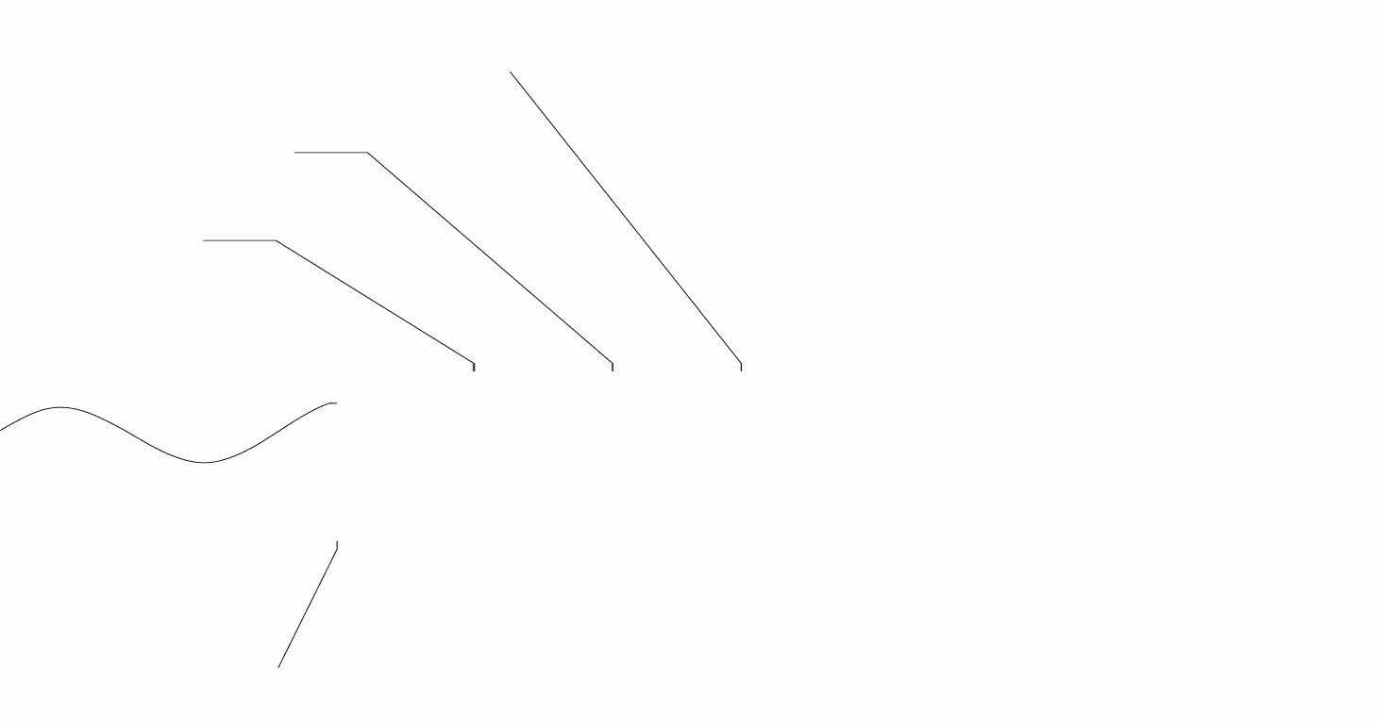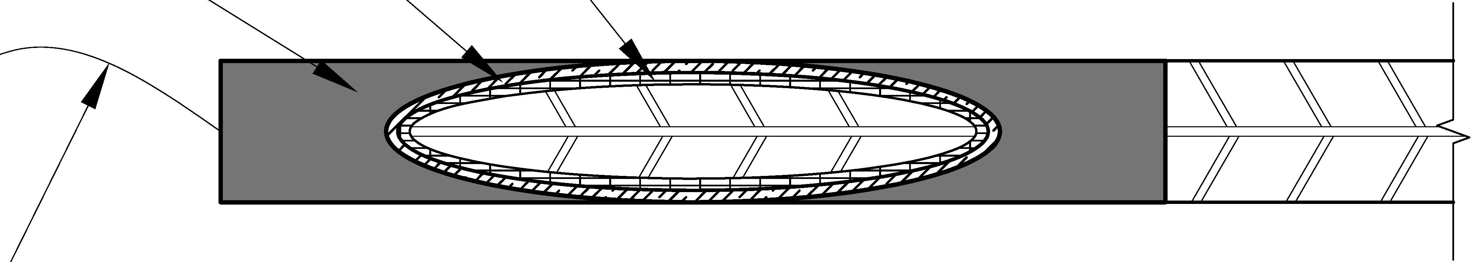

Electro Platter Tape - Two Part Epoxy

Shrink Tube

Steel Wire�

**Figure 4.10** Rebars Ends Protection

*t* = *λmlossηspecimenCfaraday*

*iMspecimen*

(4.8)

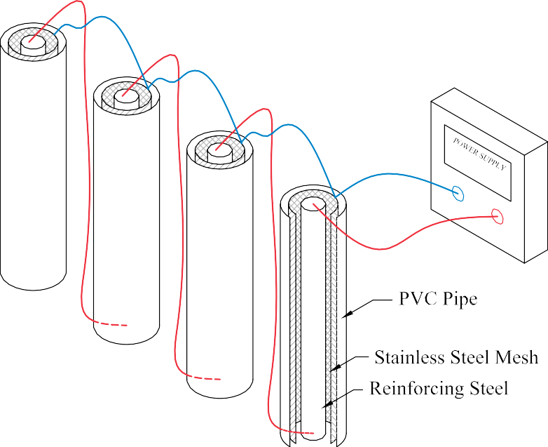

**Figure 4.11** Accelerated Corrosion Process

For the different rebar sizes and corrosion levels the current and the time of application is shown in Table 4.1.

#### Tension Tests

A series of tension tests will be performed according to ASTM A706. The main objective of this tests is to evaluate differences in the stress-strain behavior of corroded reinforcing steel. This will help in determining any reduction in the ductility of steel for this condition. In addi- tion equations 4.7 will be corroborated.

#### Buckled Bar Tension (BBT) Test

One of the limit states that control Performance Based Design is Buckling of Reinforcing steel, recent tests have been developed to determine the critical bending strain of buckling of

**Table 4.1** Accelerated Corrosion to achieve Corrosion Levels.

|  |  |  |
| --- | --- | --- |
| Corrosion Level (CL) | Mass loss (g) | time(days) |
| 5% | 1.12 | 9 |
| 10% | 2.24 | 18 |
| 15% | 3.36 | 27 |
| 20% | 4.47 | 36 |
| 25% | 5.59 | 45 |

reinforced steel [4]. The premise of the BBT Test is a material test to simulate bending and tension strain demands on a buckled bar.However those results have been developed for rebars in pristine condition, it is therefore necessary to check if available expressions to determine this limit state hold for corroded steel.

The Buckled Bar Tension Test consists in:

1. Compress a rebar specimen up to a certain level of compression strain such that the rebar will show buckling
2. The rebar is then pulled untill rupture
3. process is repeated for different levels of compression strains

This test is proposed for different levels of corrosion such that any changes on the behavior are studied and incorporated into the analysis a sequence of the test procedure is shown in Fig. 4.12. A proposed test matrix is shown in Table 4.2.

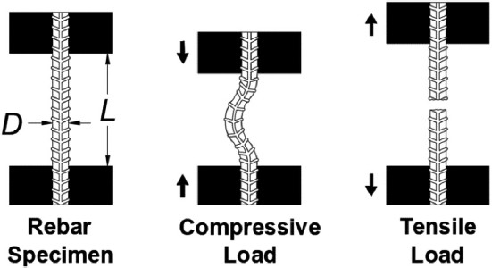

**Figure 4.12** BBT Test sequence[4]

**Table 4.2** Corroded Rebar Test Matrix

|  |  |  |  |
| --- | --- | --- | --- |
| Corroded BBT Test Matrix | | | |
| Test | Diameter of Bar | CL (%) | Number of Tests |
| Tension Test | #6 | 0 | 3 |
| 5 | 3 |
| 10 | 3 |
| 15 | 3 |
| 20 | 3 |
| 25 | 3 |
| BBT Test | #6 | 0 | 6 |
| 5 | 6 |
| 10 | 6 |
| 15 | 6 |
| 20 | 6 |
| 25 | 6 |

### Modeling of corrosion for Structural Analysis

The previous elements of corrosion explained in the previous sections are incorporated into the structural analysis mainly at the material level. The application can be outlined as follows:

* + - 1. First the time for initiation of corrosion is calculated according to the Gosh and Padgett Model [15]
      2. Then the rate of corrosion is calculated according to the Vu et al model [41]
      3. Following this the size of the rebar is reduced and the corrosion level is calculated
      4. Finally the mechanical properties of the reinforcing steel are modified with the corre- sponding corrosion level.

This process is shown in Fig. 4.13.

Obtain Level of Corrosion

CL

Reduce size of rebar db

Calculate Time to Corrosion

Tcorr

Calculate the rate of Corrosion

icorr

Modify Mechanical Properties

fy, fu

**Figure 4.13** Corrosion Modeling for Structural Analysis

This is later incorporated into the Nonlinear Structural Analysis Framework using OpenSees [27], the framework of this analysis is explained in **Chapter-5**.

## Steel Strain Aging

### Metallurgical Process

It is generally accepted that strain aging is due to the diffusion of carbon and/or nitrogen atoms in solution to dislocations that have been generated by plastic deformation. Initially, an atmo- sphere of carbon and nitrogen atoms is formed along the length of a dislocation, immobilizing it. Extended aging, however, results in sufficient carbon and nitrogen atoms for precipitates to form along the length of the dislocation[32][19].

These precipitates impede the motion of subsequent dislocations and result in some hard- ening and loss in ductility. The extent of strain aging, which is a thermally activated process, depends primarily on aging time and temperature. In general, extended aging results in a sat- uration value above which further aging has no effect [35].

A second strengthening mechanism occurs when cold deformation (alone) is applied to steels. When dislocations break away for their pinning interstitial atoms and begin the movement causing slip they begin to intersect with each other. A complex series of interactions between the dislocations occurs, causing them to pin each other, decreasing their mobility. The decreased mobility also results in higher strength, lower ductility and lower toughness. As a result, cold deformed steels already have lowered ductility and toughness before any strain aging occurs and when heating follows cold deformation, the loss in ductility and toughness is greater. It is this combination of events that is the most damaging to the toughness of structural steels [31].

### Strain aging effects in structures

Given the fact that that strain aging is the process by which steel after being subjected to large strains develops an increased strength and reduced ductility with time. It is important to include it in a time dependent analysis. Furthermore strain aging will cause an increase in the strength of the plastic hinge and as a consequence plastic hinges may formed in regions of the structures that have not been designed for such demands. The effects of strain aging may also alter the transverse reinforcement due to cold bending, making them susceptible to brittle failure[31].

According to Restrepo-Posada[35] most strain aging occurs in the first 37 days. Also [31] studied strain aging effects with respect to time for different levels of pre-strains that ranged from 2*εy −* 10*εy* and for a time frame of 3 days to 50 days, from this study it was determined that a significant effect of strain aging took place from pre-strains 5*εy* and on. Strains higher than 15*εy* indicate a performance level in which substantial damage has been induced in the

structure such that it is deemed unrepairable and therefore pre-strains higher that 15*εy* are unpractical and not studied by Momtahan et al[31].

Momtahan et al was able to correlate the increase in yield strength as a function of time and the pre-strain in reinforcing steel bars. The proposed equations are shown below:

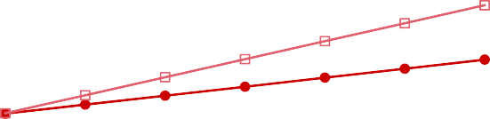

**Figure 4.14** Strain Aging effect on Yield Strength vs Time (days)

1.08

1.07

1.06

1.05

y,1.04 2εy

i

/F

t

F 1.03 5εy

y,

1.02 10εy

1.01

1.00

0.99

0 5 10 15 20 25 30 35 40

Time (Days)

For 10*εy*

For 5*εy*

For 2*εy*

*fy fyi*

*fy fyi*

*fy fyi*

= 0*.*0026*t* + 0*.*9838 (4.9)

= 0*.*0008*t* + 0*.*996 (4.10)

= 0*.*0004*t* + 0*.*9979 (4.11)

It is proposed to limit the increase in yield strength to the one obtained at 50 days which was the limit of scope of the study. These equations are plotted in Fig. 4.14

## Multiple Seismic Events

The evaluation of multiple seismic events is a topic that has been scarcely studied, however their effects have been felt in numerous earthquake sequences such as the Christchurch 2010, Umbria-Marche Earthquake 1997 and the Puerto Rico Earthquakes 2020. The hypothesis is that accumulation of damage will restart in a smaller seismic event to achieve a prescribed limit state, similar to how corrosion and other aging phenomena might impact the intensity needed to achieve a future limit state.

For this study it has been determined that not all damage in structures are dependent on multiple events but rather their condition when an event occurs as is the case for corrosion. Other damage related phenomenons such as Strain Aging depend on the loading history and are therefore dependent on the history of extreme loading events. It is therefore proposed to study corrosion on a discrete modeling of Main Shocks each independent of the other and to study the effect on Strain Aging by using a sequence of Main Shocks.

### Earthquake Selection

For this study the NGA2 West Database of earthquake records provided by the Pacific Earth- quake and Engineering Research Insitute (PEER) [2] is used. This database consists of 599 different Earthquake events that characterize the ground motions on the west coast of the contiguous United States. The data was filtered according to the following criteria:

* + - * Must be an earthquake sequence
      * Moment Magnitude *Mw* ) 5
      * *PGA >* 0*.*04
      * *PGV >* 1 cm/s
      * *V s*30 *>* 100*m/s* & *V s*30 *<* 1000 m/s
      * Lowest usable frequency is less than 1Hz
      * *Rrup <* 60*km*

From this data the main shocks found are the following earthquakes which can be sumarized in Fig. 4.15. Figure 4.15 shows the earthquakes as moment magnitude Mw vs rupture distance (*Rrup*).

* + - * Chi-chi
      * Managua
      * Livermore
      * Northridge
      * Duzce
      * Mammoth lake

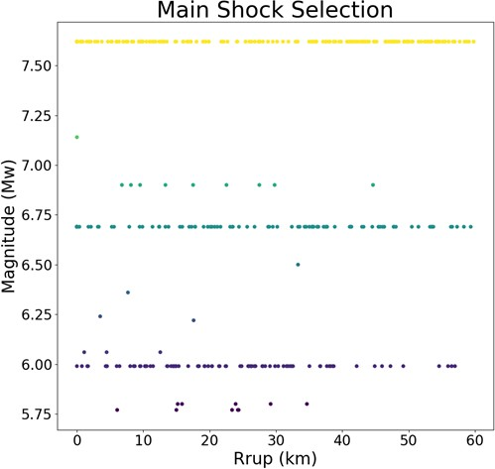

**Figure 4.15** Mainshock selection from PEER NGA West2 Database

### Discrete Modeling of Main Shock Series

The discrete modeling of mainshocks consists of using individual earthquakes that occur at different times throughout the life of the structures which correlate to a corrosion level (CL), this can be done for each of the main shocks selected after which the following data is obtained and later analyzed:

* + - * Maximum axial strain in confined concrete, cover and reinforcing steel Strains
      * Obtain the probability of exceeding a given limit state *P* (*ε > εLS, IM* )
      * The earthquakes are characterized according to an intensity measure

### Multiple Main Shock Series

To simulate the life of a structure a mainshock series consisting of 3 mainshocks for a the life of a structure is considered, three phases are considered:

1. at time *t* = 0 the structure has pristine conditions
2. Mainshock 1: pristine conditions are present. No changes to the material properties is present and no accumulation of damage has occurred.
3. Mainshock 2: significant time after time to corrosion, mainshock 2 occours and material properties have changed due to corrosion
4. Mainshock 3: corrosion and strain aging have occurred and further modified the properties of the materials.

Similar to the discrete modeling pf main shock series the following results can be obtained:

* + - * Maximum axial strain in confined concrete, cover and reinforcing steel Strains
      * Obtain the probability of exceeding a given limit state *P* (*εεLS, IM* )
      * The earthquakes are characterized according to an intensity measure

## Future Topics

* Concrete strength aging
* Welding and fatigue in steel structures
* Repair effects
* Main shock - after shock series - repair series
* Load history effects
* Degree of damage effect on confined structures behavior
* Selection of intensity measure (IM)

# Chapter 5

**Analytical Model and Preliminary Results**

In this chapter first a framework for the analysis that is performed is presented, later the basic model that is used for the analysis is presented and later calibrated and verified with experimental data available in the literature. Finally, preliminary results are presented that will give a first view for the proposed research.

## Analytical Model

### Cantilever Column

This study focuses on the behavior of a single degree of freedom (SDOF) system represent- ing a cantilever reinforced concrete column. The column is modeled as shown in Fig. 5.1 This structure is modeled in OpenSeesPy [27][49] using the *forceBeamColumn* element [37]. The forceBeamColumn element is used with two-point Gauss-Radau integration applied in the hinge regions and two-point Gauss integration applied on the element interior for a total of six in- tegration points [37]. The force-based formulation requires only a single element to accurately represent the full nonlinear deformation of the member and the integration scheme selected pre- vents the loss of objectivity during softening response while also providing integration points at the member ends [6],[37]. The element requires the length of plasticity be defined at each end of the member, for which the tension-based rectangular plastic hinge length is calculated using the following expressions [18]:

*Lpc* = *k ∗ Leff* + 0*.*4*D* (5.1)

*k* = 0*.*2 *∗* (*Fu/Fy −* 1) � 0*.*08 (5.2)

*Lpt* = *Lpc* + *γ ∗ D* (5.3)

For single bending the parameter *γ* is:

*γ* = 0*.*33 (5.4)

The two-point Gauss-Radau integration is applied such that each end node integration is weighted equal to the specified plastic hinge length, as illustrated in Fig. 5.2. Therefore, strains recorded at the end sections represent accurate values even in the case where deformation localizes to the ends from strain-softening behavior. For the case of the cantilever column considered, only one plastic hinge length is defined, and the opposite end is given an arbitrary unit length.

The section of the column is shown in Fig. 5.3, the section is discretized with concrete and steel material fibers. Concrete fibers are modeled using the *Concrete*01 material, mod- ified for confined material strength based on the Mander confined concrete model [26]. The *Steel*02 material, based on the Giuffre-Menegotto-Pinto model [12] is used for the longitudinal reinforcement with recommended parameters (*b* = 0*.*01*, R*0 = 20*, cR*1 = 0*.*925*, cR*2 = 0*.*15).

### Strain Penetration

The strain penetration needs to be considered to take into account the additional deformation due to anchorage of the reinforcement into the foundation, since the strains of tension in the reinforcement will drop to zero at a depth equal to the true development length of the rebar [34]. Experimental studies have generally reported that this end rotation contributes up to 35% to the lateral deformation of flexural members[48] and it is therefore important to incorporate into the analytical model. A way to capture this effect is by using a zero-length section element implemented in nonlinear fiber-based analysis of concrete structures, this is available in the material library of OpenSeesPy as *BondSP* 1 [48] this is material model used for the steel fibers of the zero-length section element.

The required parameters for this model are:

* + - * *Fy* Yield strength of the reinforcement steel
      * *Sy* Rebar slip at member interface under yield stress (see Eq. 5.5)



 

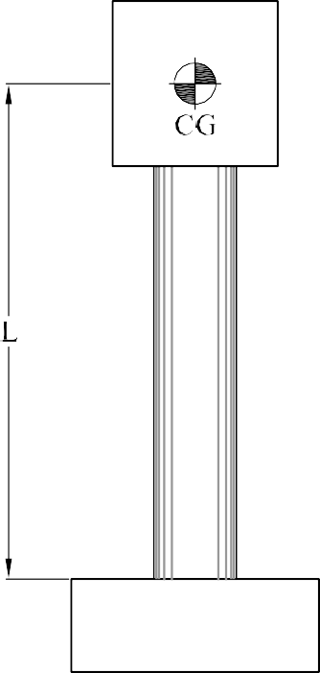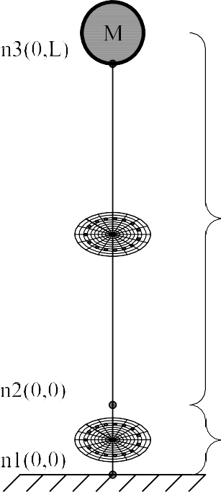**Figure 5.1** Structural Model a) SDOF Column b) Structural Model

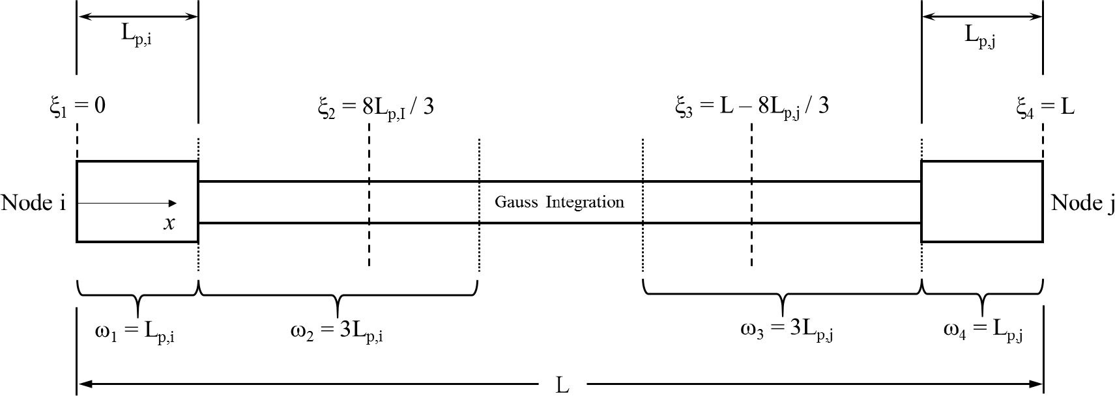

**Figure 5.2** End point plastic hinge method [37]

**Figure 5.3** Section of the RC Column

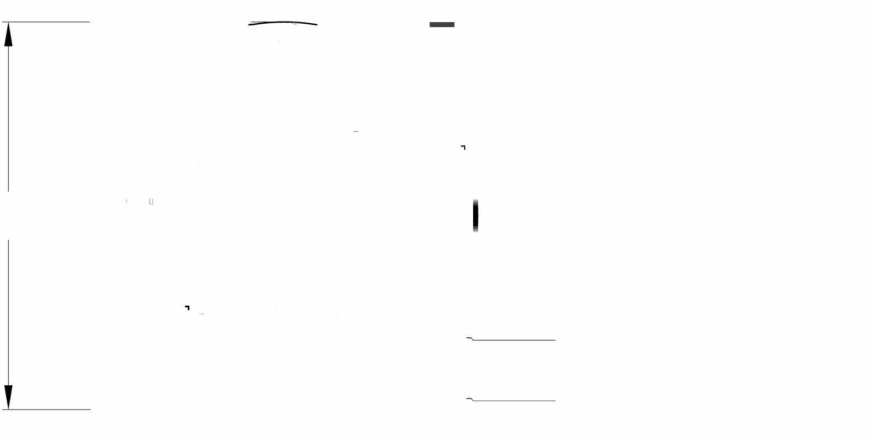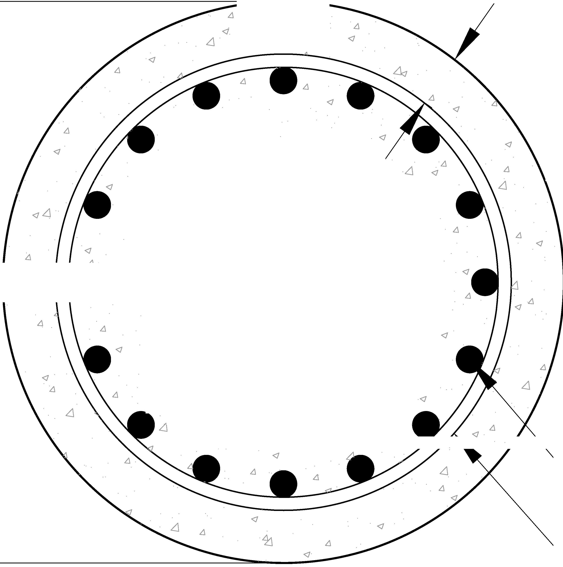

* + - * *Fu* Ultimate strength of the reinforcement steel
      * *Su* Rebar slip at the loaded end at the bar fracture strength a value of 35*Sy* is recom- mended [48]
      * *b* Initial hardening ratio in the monotonic slip vs. bar stress response *b* = 0*.*45 is recom- mended [48]
      * *R* Pinching factor for the cyclic slip vs. bar response *R* = 1*.*01 is recommended [48]
      * *db* Rebar diameter
      * *f Ic* Concrete compressive strength of the adjoining connection member
      * *α* Parameter used in the local bond-slip relation and can be taken as *α* = 0*.*4 in accordance with CEB-FIP Model Code 90 [8]

Bar slip is calculated as:

*Sy*(*in*) = 0*.*1

*d F*

4000✓*f I* (2*α* + 1)

*c*

*yb*

1

*α*

+ 0*.*013(*in*) (5.5)

### Design Limit States

Design limit states are defined on the basis of strains in the material since they can more accurately represent the different performance level of a structure. Structure limit states are

defined for tension strains in the rebars or compression strains in the concrete core. The values recommended in typical performance based design of reinforced concrete bridge columns are shown in Table 5.1. The serviceability limit states correspond to the compression strain at which concrete cover begins to crush and the peak tension strain which results in residual crack widths of approximately 1 mm. These limits are generally accepted as nominal limit states for RC members. The compression limit state for damage control is defined by the expresion shown in eq. 5.6 and it refers to the compression strain in the confined concrete at which fracture of the transverse reinforcement confining the core occurs [34]. This equation is obtained using the strain-energy balance between that absorbed by the confined core concrete and the capacity of the confining steel. The tension damage control limit state is defined by the strain at the onset of buckling which can be expressed according to 5.7, this equation demonstrated accurate predictions of the onset of bar buckling on physical tests in SDOF Concrete Column [17]. The bar buckling limit state could change as a result of the experimental campaign proposed in Chapter 4.

*ε* = 0*.*009 *−* 0*.*3 *Ast* + 3*.*9 *fyhe*

(5.6)

*c,spiralyield*

*Ag Es*

*ε* = 0*.*03 + 700*ρ*

*fyhe P*

*−* 0*.*1

(5.7)

*s,BB*

*s Es*

*fcIAg*

**Table 5.1** Design Limit States

|  |  |  |
| --- | --- | --- |
| Limit State | Concrete Limit State *εc*(*in/in*) | Reinforcing Steel Limit State *εs*(*in/in*) |
| Serviciability | 0.004 | 0.015 |
| Damage Control | Eq. 5.6 | Eq. 5.7 |

## Comparison with existing physical Tests

### Pristine Condition Columns

Goodnight et al performed a total of 30 circular columns [17]. From this set of experiments, a sample of one was taken to calibrate the analytical model. The test performed by Goodnight et al on an SDOF cantilever column shows similar geometry to that presented in Fig. 5.2. The

parameters used in this large scale test were:

* + - * Diameter *D* = 24*.*0*inch*
      * Height of the column *L* = 8*.*0*ft*
      * Yield strength of steel *fy* = 574*.*0*MPa*
      * Ultimate strength of steel *fu* = 753*.*3 *∗ MPa*
      * Longitudinal steel volumetric ratio *ρs* = 1*.*5%
      * Transverse steel volumetric ratio *ρv* = 1*.*0%
      * Strength of concrete at 8 days *fcI* = 39*.*8*MPa*

These parameters are used in the analytical program. The results show good agreement between the analytical model and the experimental results as shown in Fig. 5.4. This helps to assure that the results obtained from the model predict the overall system behavior.

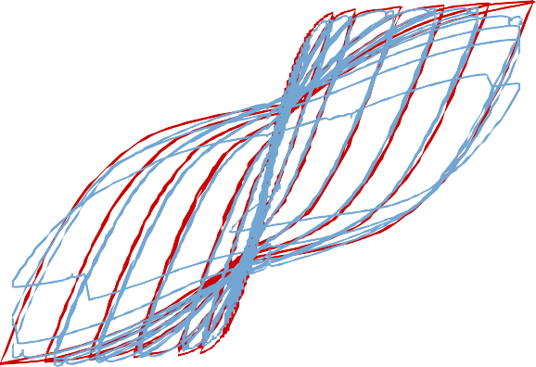

**Figure 5.4** Force-Displacement results from experimental results [18] and analytical model

100

80

60

40

ip) 20 (k e 0

Forc -20

-40

-60 OpenSees

-80 Test Results

-100

-8.00 -6.00 -4.00 -2.00 0.00 2.00 4.00 6.00 8.00

Displacement (in)

### Accelerated Corrosion Columns

Similarly Ma et al performed a series of quasi static tests on RC columns with different corrosion levels and axial load ratios [24]. From [24] the test with a corrosion level *CL* = 9*.*5% was taken since the other tests presented in their study had excesively high axial load ratios which are not common in RC bridges. The results from Ma et al test [24] were used to compare against analytical model. The column had the following parameters:

* + - * Diameter *D* = 260*.*0*mm*
      * Height of the column *L* = 820*.*0*ft*
      * Yield strength of steel *fy* = 375*.*0*MPa*
      * Ultimate strength of steel *fu* = 572*.*3 *∗ MPa*
      * Longitudinal steel volumetric ratio *ρs* = 1*.*5%
      * Transverse steel volumetric ratio *ρv* = 1*.*0%
      * Strength of concrete at 8 days *fcI* = 39*.*8*MPa*
      * Corrosion level *CL* = 9*.*5%

Using equation Eq. 4.7 the material properties of the reinforcing steel were modified accord- ingly. Fig. 5.6 shows that the results obtained from the analytical model capture the response of the structure before the system degrades. Their study did not report if bar buckling and bar frac- ture occurred, however, using the equation Eq. 5.7 the bar buckling limit state is *εs,BB* = 0*.*024

, while figure Fig. **??** shows that a peak tension strain of *εs* = 0*.*023 was reached. This result shows that equation Eq. 5.7 may be overpredicting the buckling limit state for corroded rebars, however the proposed corroded BBT test results will show the adequacy of Eq. 5.7.

## Analytical Framework

An analytical framework is establishedto perform a series of nonlinear time history analyses (NLTHA). From these analyses it is possible to determine the effects of damage in the perfor- mance of structures. The proposed analytical framework process consists:

1. Geometrical Properties of the SDOF column
2. Properties of the material are evaluated (i.e. water to cement ratio, cover)

|  |  |  |  |  |  |  |  |  |  |
| --- | --- | --- | --- | --- | --- | --- | --- | --- | --- |
|  |  |  |  |  |  |  |  |  |  |
|  |  |  |  |  |  |  |  |  |  |
|  |  |  |  |  |  |  |  |  |  |
|  |  |  |  |  |  |  |  |  |  |
|  |  |  |  |  |  |  |  |  |  |
|  |  |  |  |  |  |  |  |  |  |
|  |  |  |  |  |  |  |  |  |  |
|  |  |  |  |  |  |  |  |  |  |
|  |  |  |  |  |  |  |  |  |  |
|  |  |  |  |  |  |  |  |  |  |

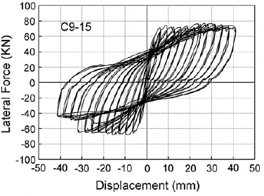**Figure 5.5** Force-Displacement results from experimental RC column with corrosion in logitudinal bar (CL=9.5%) results [24] and analytical model (shown in lightblue)



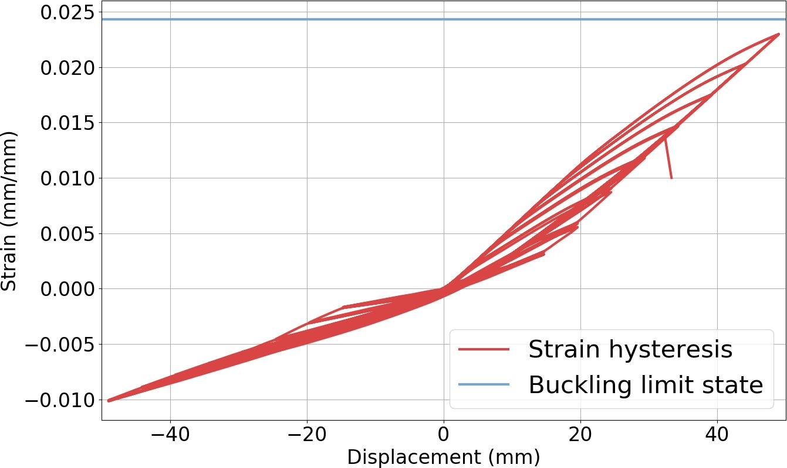

**Figure 5.6** Strain hysteresis from experimental RC column with corrosion in logitudinal bar (CL=9.5%) results from analytical model

**Table 5.2** Analysis Matrix

|  |  |  |
| --- | --- | --- |
| ANALYSIS MATRIX | | |
| Description | Parameter | Range |
| Diameter of Column | D | 30-90 in |
| Column Length to Diameter Ratio | L/D | 2-8 |
| Longitudinal Ratio | *ρs* | 0.01-0.04 |
| Transverse Volumetric Ratio | *ρv* | 0.005-0.015 |
| Axial Load Ratio | ALR | 0.05-0.2 |
| water to cement ratio | w/c | 0.36-0.6 |
| cover | c | 1.5-3 in |
| Time/Condition | CL | 5%-20% |

1. For equal periods of time the Time Dependent Properties are modified
2. Nonlinear Time History Analysis are performed for discrete ground motions or sequence of ground motions
3. Results are obtained and evaluated

The analytical parameters used of this study are shown in Table 5.2

## Results from NLTHA

This section presents the results obtained from a non-linear time history analysis (NLTHA) performed using OpenSeesPy [49]. The structure was subjected to a total of 18 earthquake records. The main responses obtained from these analyses correspond to the maximum strain obtained for the different levels of corrosion.

The structure used for this results currently correspond to the parameters shown in section

5.2.1. The structure was analyzed for a range of corrosion level [1.5%-13%] in the longitudinal rebars.

### Effect on structure response

An example of the results obtained using NLTHA, figures Fig. **??** and Fig. 5.8 are presented. These results are extracted from the response of the structure to the Chi-Chi earthquake. Fig. **??** Shows the global system response and Fig. 5.8 shows the stress-strain response of the extreme fiber of reinforcing steel. These results show that as corrosion increases the demands imposed on the structure increases and therefore become prone to sustaining more damage.

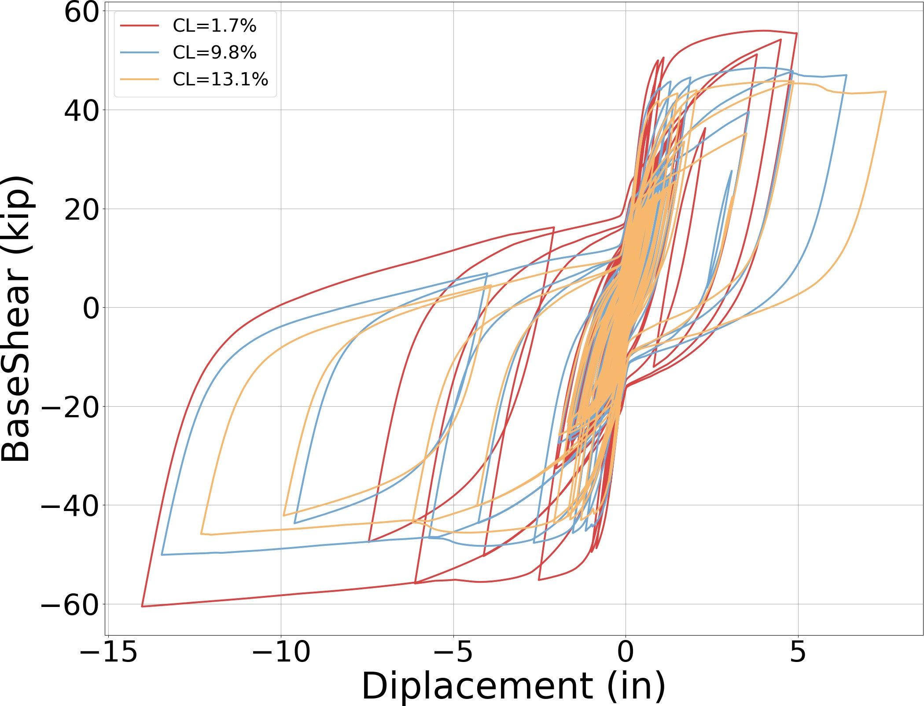

**Figure 5.7** Force-Displacement results

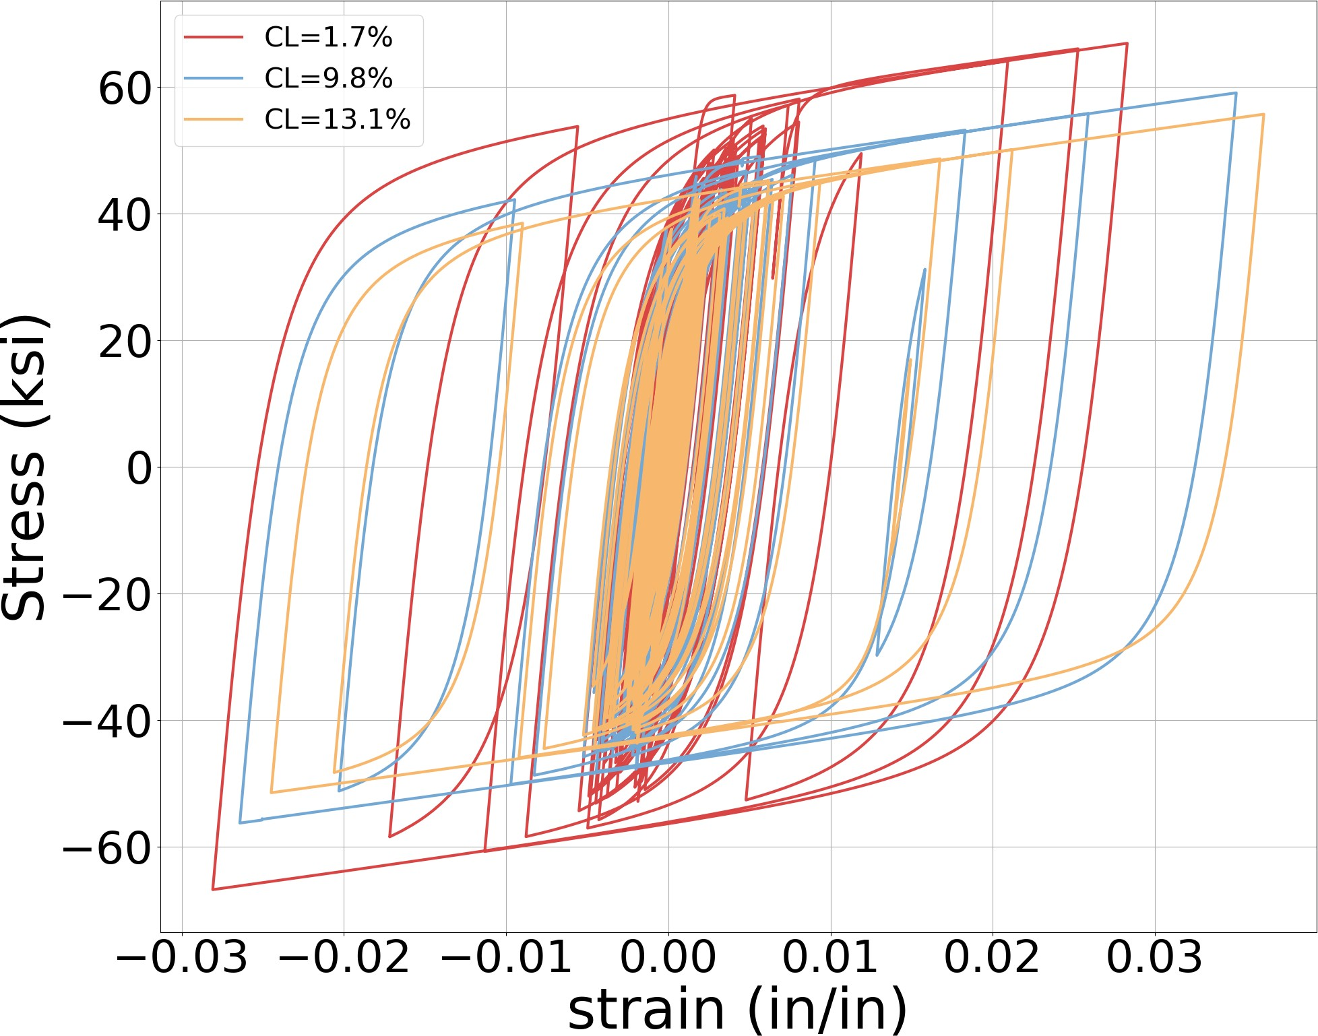

**Figure 5.8** Stress strain response for extreme rebar location

### Cumulative distribution functions

To sumarize the results obtained for all the analyzed earthquakes, a cumulative distribution function is used. The methodology employed corresponds to that recommended by Baker et al [3]. Figures Fig. 5.9 and Fig. 5.10 present a series of CDF graphs for steel yielding limit states as an example of the results that can be obtained from the analysis. More analysis will help improve these results. These figures however show that the intensity measre of spectral displacement at first effective period(*IM* = *Sd*(*T*1)) presents better correlation than those obstained by seelcting the intesnity measure as peak ground acceleration (*IM* = *PGA*). Thus it shows that *IM* = *Sd*(*T*1) is a better intensity measure than *IM* = *PGA*, these correlates well with a recent study performed by Krish et al [22].

**Figure 5.9** CDF of steel yielding limit state using IM=PGA

1.00

0.90

0.80

0.70

) 0.60

LS

ε

ε> 0.50

P( 0.40 CL=1.7%

0.30 CL=9.8%

0.20 CL=13.1%

0.10

0.00

0.00 0.50 1.00 1.50 2.00 2.50 3.00

PGA(g)

**Figure 5.10** CDF of steel yielding limit state using *IM* = *Sd*(*T*1)

1.00

0.90

0.80

0.70

0.60

)

LS 0.50

ε>ε

P( 0.40 CL=1.7%

0.30

CL=9.8%

0.20 CL=13.1%

0.10

‐

‐ 1.00 2.00 3.00 4.00 5.00 6.00 7.00 8.00

Sd(T1) (in)

### Results discussion

* + - * The results show that there is an increase in the demands as the corrosion in the structure increases. This is clearly shown in Fig. 5.10. However more results will help improve the correlation
      * Results shown in Fig. 5.9 and Fig. 5.10, show that *IM* = *Sd*(*T*1) is a better inensity measure than *IM* = *PGA*
      * The outcomes from the experimental campaign will further improve the results obtained in the analytical phase
      * The experimental phase will also provide an improved methodology to mimic the behavior of corroded reinforcing steel that is embedded inside the concrete
      * The inclusion of additional aging conditions in the analysis will provide a realistic analysis of aging RC Columns

#### BIBLIOGRAPHY

1. Amato, A., Azzara, R., Chiarabba, C., Cimini, G. B., Cocco, M., Di Bona, M., Margheriti, L., Mazza, S., Mele, F., Selvaggi, G., Basili, A., Boschi, E., Courboulex, F., Deschamps, A., Gaffet, S., Bittarelli, G., Chiaraluce, L., Piccinini, D. & Ripepe, M., “The 1997 Umbria- Marche, Italy, earthquake sequence: A first look at the main shocks and aftershocks,” *Geophysical Research Letters*, **25**, no. 15, pp. 2861–2864, 1998.
2. Ancheta, T. D., Darragh, R. B., Stewart, J. P., Seyhan, E., Silva, W. J., S-J Chiou, B., Wooddell, K. E., Graves, R. W., Kottke, A. R., Boore, D. M., Kishida, T. & Donahue,

J. L., “NGA-West2 Database,” 2014.

1. Baker, J. W., “Efficient analytical fragility function fitting using dynamic structural anal- ysis,” *Earthquake Spectra*, **31**, no. 1, pp. 579–599, 2015.
2. Barcley, L. & Kowalsky, M., “Critical Bending Strain of Reinforcing Steel and Buckled Bar Tension Test,” *ACI Materials Journal*, **116**, no. 3, 2019.
3. Bradley, B. A. & Cubrinovski, M., “NEAR-SOURCE STRONG GROUND MOTIONS OBSERVED IN THE 22 FEBRUARY 2011 CHRISTCHURCH EARTHQUAKE,” Tech. Rep.
4. Calabrese, A., Almeida, J. P. & Pinho, R., “Numerical issues in distributed inelasticity modeling of rc frame elements for seismic analysis,” *Journal of Earthquake Engineering*, **14**, no. sup1, pp. 38–68, 2010.
5. Choe, D.-E., Gardoni, P., Rosowsky, D. & Haukaas, T., “Probabilistic capacity models and seismic fragility estimates for RC columns subject to corrosion,” *Reliability Engineering & System Safety*, **93**, no. 3, pp. 383–393, 2008.
6. Comit´e Euro-Intenational du Bet´on, *CEB-FIP Model Code 90*, 1st. London, 1993.
7. Du, Y. G., Clark, L. A. & Chan, A. H. C., “Residual Capcaity of Corroded Reinforcing Bars,” *Magazine of Concrete Research*, **57**, no. 3, pp. 135–147, 2005.
8. Enright, M. P. & Frangopol, D. M., “Probabilistic analysis of resistance degradation of reinforced concrete bridge beams under corrosion,” *Engineering Structures*, **20**, no. 11, pp. 960–971, 1998.
9. Fajfar, P., “Equivalent ductility factors, taking into account low-cycle fatigue,” *Earth- quake Engineering & Structural Dynamics*, **21**, no. 10, pp. 837–848, 1992.
10. Filippou, F. C., Popov, E. & Bertero, V., “Effects of bond deteroriation on hysteretic behavior of renforce concrete coint,” Tech. Rep. August, 1983, p. 212.
11. Ghods, P., Isgor, O. B., McRae, G. & Miller, T., “The effect of concrete pore solution composition on the quality of passive oxide films on black steel reinforcement,” *Cement and Concrete Composites*, **31**, no. 1, pp. 2–11, 2009.
12. Ghods, P., Isgor, O. B., McRae, G. A. & Gu, G. P., “Electrochemical investigation of chloride-induced depassivation of black steel rebar under simulated service conditions,” *Corrosion Science*, **52**, no. 5, pp. 1649–1659, 2010.
13. Ghosh, J. & Padgett, J. E., “Aging Considerations in the Development of Time-Dependent Seismic Fragility Curves,” *Journal of Structural Engineering*, **136**, no. 12, pp. 1497–1511, 2010.
14. Ghosh, J., Padgett, J. E. & S´anchez-Silva, M., “Seismic Damage Accumulation in Highway Bridges in Earthquake-Prone Regions,” *Earthquake Spectra*, **31**, no. 1, pp. 115–135, 2015.
15. Goodnight, J. C., Kowalsky, M. J. & Nau, J., “Strain limit states for circular rc bridge columns,” *Earthquake Spectra*, **32**, no. 3, pp. 1627–1652, 2016.
16. Goodnight, J. C., Kowalsky, M. J. & Nau, J. M., “Effect of load history on perfor- mance limit states of circular bridge columns,” *Journal of Bridge Engineering*, **18**, no. 12, pp. 1383–1396, 2013.
17. Hosseini, S., Heidarpour, A., Collins, F. & Hutchinson, C. R., “Effect of strain ageing on the mechanical properties of partially damaged structural mild steel,” *Construction and Building Materials*, **77**, pp. 83–93, 2015.
18. Khashaee, P. & Eeri, M, “Damage-based Seismic Design of Structures,” *Earthquake Spec- tra*, **21**, no. 2, pp. 371–387, 2005.
19. Krawinkler, H., “Performance Assessment of Steel Component,” *Earthquake Spectra*, **3**, no. 1, pp. 27–41, 1987.
20. Krish, Z. F., “Rapid Repair of Reinforced Concrete Bridge Columns Subjected to Seismic Loading via Plastic Hinge Relocation,” PhD thesis, North Carolina State University, 2018.
21. Kunnath, S. K., Reinhorn, A. M. & Lobo, R. F., “IDARC Version 3.0: A Program for the Inelastic Damage Analysis of RC Structures,” **818**, no. 1992, pp. 1–20, 1992.
22. Ma, Y., Che, Y. & Gong, J., “Behavior of corrosion damaged circular reinforced concrete columns under cyclic loading,” *Construction and Building Materials*, **29**, pp. 548–556, 2012.
23. Mackie, K. R. & Stojadinovi´c, B., “Performance-based seismic bridge design for dam- age and loss limit states,” *Earthquake Engineering & Structural Dynamics*, **36**, no. 13, pp. 1953–1971, 2007.
24. Mander, J. B., Priestley, M. J. N. & Park, R., “Theoretical stress&#x2010;strain model for confined concrete,” *Journal of Structural Engineering*, **114**, no. 8, pp. 1804–1826, 1988.
25. McKenna, F., Scott, M. H. & Fenves, G. L., “Nonlinear finite-element analysis software architecture using object composition,” *Journal of Computing in Civil Engineering*, **24**, no. 1, pp. 95–107, 2010.
26. Meda, A., Mostosi, S., Rinaldi, Z. & Riva, P., “Experimental evaluation of the corrosion influence on the cyclic behaviour of RC columns,” *Engineering Structures*, **76**, pp. 112– 123, 2014.
27. Mehta, P. K. & Monteiro, P. J. M., *Concrete: Microstructure, Properties, and Materials*, 4th ed. McGraw Hill, 2014.
28. Miranda, E., Archbold, J., Heresi, P., Messina, A., Rosa, I., Robertson, I., Mosalam, K., Kijewski-Correa, T., Prevatt, D. & Roueche, D., “PRJ-2712 — StEER - Puerto Rico Earthquake Sequence December 2019 to January 2020: Field Assessment Structural Team (FAST) Early Access Reconnaissance Report (EARR),” Structural Extreme Events Re- connaissance, Tech. Rep., 2020, p. 173.
29. Momtahan, A., Dhakal, R. P. & Rieder, A., “Effects of strain-ageing on New Zealand reinforcing steel bars,” *Bulletin of the New Zealand Society for Earthquake Engineering*, **42**, no. 3, pp. 179–186, 2009.
30. Overby, D., Kowalsky, M. & Seracino, R., “Stress-strain response of A706 grade 80 rein- forcing steel,” *Construction and Building Materials*, **145**, pp. 292–302, 2017.
31. Padgett, J. E. & Desroches, R., “Bridge Functionality Relationships for Improved Seismic Risk Assessment of Transportation Networks,” *Earthquake Spectra*, **23**, no. 1, pp. 115– 130, 2007.
32. Priestley, M., Calvi, G. M. & Kowalsky, M. J., *Displacement-Based Seismic Design of Structures*, 1st. Pavia, Italy: IUSS Press, 2007.
33. Restrepo-Posada, J., Dodd, L. L., Park, R & Cooke, N, “Variables Affecting Cyclic Be- havior of Reinforcing Steel,” *Journal of Structural Engineering*, **120**, no. 11, pp. 3178– 3196, 1994.
34. Roufaiel, M. S. L. & Meyer, C., “ANALYTICAL MODELING OF HYSTERETIC BE- HAVIOR OF R/C FRAMES,” Tech. Rep.
35. Scott, M. H. & Fenves, G. L., “Plastic Hinge Integration Methods for Force-Based Beam- Column Elements,” *Journal of Structural Engineering*, **132**, no. 2, pp. 244–252, 2006.
36. Shekhar, S., Ghosh, J. & Padgett, J. E., “Seismic life-cycle cost analysis of ageing highway bridges under chloride exposure conditions: modelling and recommendations,” *Structure and Infrastructure Engineering*, **14**, no. 7, pp. 941–966, 2018.
37. Stewart, M. G. & Rosowsky, D. V., “Time-dependent reliability of deteriorating reinforced concrete bridge decks,” *Structural Safety*, **20**, no. 1, pp. 91–109, 1998.
38. Thoft-Christensen, P., “Corrosion and Cracking of Reinforced Concrete,” *Life-Cycle Per- formance of Deteriorating Structures: Assessment, Design and Management*, 2003, pp. 26– 36.
39. Vu, K. A. T. & Stewart, M. G., “Structural reliability of concrete bridges including improved chloride-induced corrosion models,” *Structural Safety*, **22**, no. 4, pp. 313–333, 2000.
40. Weyers, R. E., Fitch, M. G., Larsen, E. P., A1-Qadi, I. L., Chamberlin Albany, W. P., York,

N. & Hoffman, P. C., “Service Life Estimates,” Strategic Highway Research Program, Washington DC, Tech. Rep., 1994.

1. Williams, M. S. & Sexsmith, R. G., “Seismic Damage Indices for Concrete Structures: A State-of-the-Art Review,” *Earthquake Spectra*, **11**, no. 02, pp. 319–349, 1995.
2. Y. Liu & R. E. Weyers, “Modeling the Time to Corrosion Cracking in Chloride contam- inated Reinforced Concrete Structures,” *ACI Materials Journal*, **95**, no. 6, pp. 675–680, 1998.
3. Yang, S.-Y., Song, X.-B., Jia, H.-X., Chen, X. & Liu, X.-L., “Experimental research on hysteretic behaviors of corroded reinforced concrete columns with different maximum amounts of corrosion of rebar,” *Construction and Building Materials*, **121**, pp. 319–327, 2016.
4. Young-Ji Park, B., H-S Ang, A. & Asce, F, “Mechanistic seismic damage model for reinforced concrete,” *Journal of Structural Engineering*, **111**, no. 4, pp. 722–739, 1985.
5. Yuan, Z., Fang, C., Parsaeimaram, M. & Yang, S., “Cyclic Behavior of Corroded Rein- forced Concrete Bridge Piers,” *Journal of Bridge Engineering*, **22**, no. 7, 2017.
6. Zhao, J. & Sritharan, S., “Modeling of strain penetration effects in fiber-based analysis of reinforced concrete structures,” *ACI Structural Journal*, **104**, no. 2, pp. 133–141, 2007. arXiv: arXiv:1011.1669v3.
7. Zhu, M., McKenna, F. & Scott, M. H., “OpenSeesPy: Python library for the OpenSees finite element framework,” *SoftwareX*, **7**, pp. 6–11, 2018.